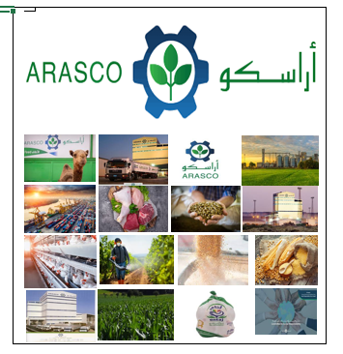

PROJECT: SAP READINESS ASSESSMENT

BUSINESS BLUEPRINT

Production Planning & Material Requirement Planning

V 1.0

30thJan 24

**Company General Use  Restricted  Confidential  Government Confidential**

|  |  |  |  |  |
| --- | --- | --- | --- | --- |
| **Description** | **Name** | **Job Title** | **Date** | **Signature** |
| **Prepared By** | PP Consultant | TechM Consultant | 27th Jan 24 |  |
| **Reviewed By** | Jeelani Basha | ARASCO IT - SAP PP | 30th Jan 24 |  |
| **Reviewed By** | Sheik Shajahan | ARASCO IT - SAP PP | 30th Jan 24 |  |
| **Reviewed By** | Project Managers | TechM and ARASCO Project Managers |  |  |
| **Approved By** | Krishnappa J. Jangal | IT Director |  |  |

**Table of Contents**

1. GLOSSARY OF TERMS 5

2. About ARASCO 7

2.1 Business organization structure 7

2.2 ARASCO Business Overview 8

2.3 ARASCO Feed 8

2.4 ARASCO Food 8

2.5 MEFSCO (Middle East Food Solutions Company ) 8

2.6 IDAC Merieux 9

2.7 ALEMAR International 9

2.8 ARASCO Logistics 9

3. ARASCO Production planning Overview 10

3.1 Arasco Feed 10

3.1.1 Requirement:- 11

3.1.2 Recommendation:- 11

3.2 Arasco Food 11

3.2.1 Requirements: 13

3.2.2 Recommendations: 13

3.3 Arasco Mefsco 13

3.3.1 Requirement:- 14

3.3.2 Recommendation:- 14

4. PRODUCTION PLANNING AND CONTROL – PROCESS MANUFACTURING 15

4.1 Overview 15

4.1.1 Purpose of this Document 15

4.1.2 Scope of this Documents 15

5. ORGANIZATIONAL UNIT 18

5.1 Company Code 18

5.2 Plant 20

5.3 Store 22

6. MASTER DATA / CONFIGURATION OBJECTS 23

6.1 Material Master 24

6.1.1 Material Type 24

6.1.2 Material Views 25

6.2 Bill of Material (BNK) 42

5.2.1 Information Required for BOM 43

5.2.2 Creation of BOM Process Flow 45

6.3 Resource (BNJ) 46

5.3.1 Scheduling 46

5.3.2 Costing 46

5.3.3 Capacity Requirement Planning 46

5.3.4 Information Required for Resource 48

5.3.5 Creation of Resource Process Flow 51

6.4 Master Recipe (BNL) 52

5.4.1 Information Required for Master Recipe 53

5.4.2 Creation of Recipe Process Flow 55

6.5 Production Version 56

6.6 Factory Calendar and Planning Calendar 56

7. Overall Process flow for MRP 60

8. Sales and Operation Planning 60

9. Demand Management 63

10. Long Term Planning 63

11. Master Production Scheduling 63

12. Material Requirement Planning 63

13. Re-order point planning 64

14. PROCESS ORDER MANAGEMENT 65

14.1 Process planning 65

14.1.2 The process flow for order creation is following: 66

14.2 Process Order Execution 67

14.2.1 Confirmations 67

14.2.2 Information Required for Confirmations 68

14.2.3 Processes for Confirmation 68

14.2.4 Goods Issuance 68

14.2.5 Goods Receipt 69

14.2.6 Re-Processing 69

14.2.7 Process Order Configuration Data 70

14.3 Order Closing 75

14.3.1 Technical Completion of Production Order (TECO) 75

14.3.2 Process Order Settlement 75

14.3.3 Closing Process Order 75

14.3.4 Prerequisites for Order Close 76

15. Re-processing 76

15.1 Process Definition 76

15.2 Re-processing OF Semi-Finished and Finished 76

16. Reports 77

17. Advantage of S4 Hana Production planning VS ECC Production Planning. 80

18. Business Process Master List 83

19. Proposed Scope of work 84

20. Technical Scope 85

20.1 Existing RICEF 85

20.2 Integration 86

20.3 RICEF Requirement 86

# GLOSSARY OF TERMS

|  |  |
| --- | --- |
| Description | Short |
| Bill of Material | BOM |
| Controlling | CO |
| Delivery Challan | DC |
| Down Payment Requirement | DPR |
| Financial Accounting | FI |
| Goods Issue | GI |
| Goods Receipt | GR |
| Goods Receipt/Invoice Receipt | GR/IR |
| Goods Received Inspection Note | GRIN |
| Human Resource | HR |
| Logistic Information System | LIS |
| Material Master | MAT |
| Materials Management | MM |
| Material Inspection Characteristics | MIC |
| Material Issue Request | MIR |
| Material Request | MR |
| Material Requirements Planning | MRP |
| Product Group | PG |
| Planning Hierarchy | PH |
| Planned Independent Requirement | PIR |
| Planned Order | PLO |
| Plant Maintenance | PM |
| Purchase Order | PO |
| Production Planning & Control | PPC |
| Production Planning and Material Control | PPMC |
| Purchase Request | PR |
| Purchase Requisition | PRQ |
| Production Order | PRO |
| Planning Table | PTB |
| Planning Type | PTE |
| Quality Management | QM |
| Rejection Area | RA |
| Request for Quotation | RFQ |
| Receiving Inspection Report | RIR |
| Recipe | RTG |
| Sales & Distribution | SD |
| Semi-Finished Good | SFG |
| Sales & Operations Planning | SOP |
| Supply Volume Production | SVP |
| Work Centers | WC |

# About ARASCO

Arabian Agricultural Services Company (ARASCO) stands as a prominent entity specializing in the supply of food and ensuring food security. It plays a significant role in enabling others to produce top-notch food for both humans and livestock.

As a closed joint stock company, ARASCO is a privately owned feed-to-food enterprise with Saudi Arabian shareholders. The company is headquartered in Riyadh and operates across various business segments and factories situated in Riyadh, Kharj, and Dammam, boasting an employee strength of nearly 3,000.

ARASCO serves as the parent company for six strategic business units, all sharing a common vision of bolstering food security and sustainability in the nation. The focus lies in delivering superior-quality animal feed products, poultry, agricultural, veterinary, and animal farming products, along with food ingredients. The company also offers comprehensive food analytical services and solutions, coupled with logistics service

## Business organization structure

ARASCO has following Strategic Business Units (SBU):

* ARASCO Feed
* ARASCO Food
* MEFSCO
* IDAC Meriux
* ALEMAR International
* ARASCO Logistics

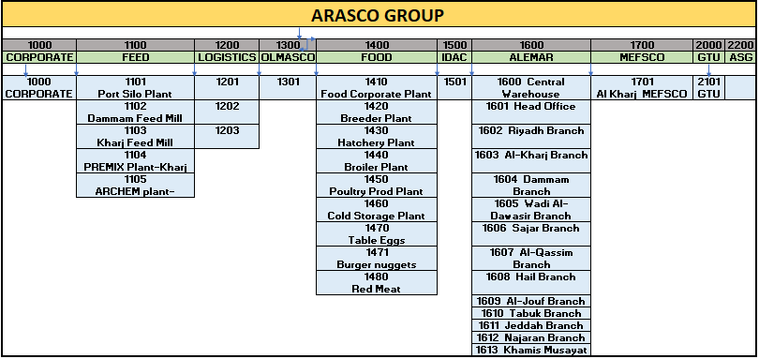

## ARASCO Business Overview

SAP Production planning module is partially used with minimum functionalities of SAP PP in the following business units of ARASCO;

PP

|  |  |  |  |  |  |  |  |  |
| --- | --- | --- | --- | --- | --- | --- | --- | --- |
| **1000** | **1100** | **1200** | **1300** | **1400** | **1500** | **1600** | **1700** | **2000** |
| **CORPORATE** | **FEED** | **LOGISTICS** | **OLMASCO** | **FOOD** | **IDAC** | **ALEMAR** | **MEFSCO** | **GTU** |
| NO | YES | NO | NO | YES | NO | NO | YES | NO |

MRP

|  |  |  |  |  |  |  |  |  |
| --- | --- | --- | --- | --- | --- | --- | --- | --- |
| **1000** | **1100** | **1200** | **1300** | **1400** | **1500** | **1600** | **1700** | **2000** |
| **CORPORATE** | **FEED** | **LOGISTICS** | **OLMASCO** | **FOOD** | **IDAC** | **ALEMAR** | **MEFSCO** | **GTU** |
| NO | YES | YES | YES | YES | YES | YES | YES | YES |

## ARASCO Feed

ARASCO Feed holds the distinction of being the largest manufacturer of Livestock Feed, encompassing Wafi feed, Lamb Starter feed, and Wafi Breeder feed. The company is also a key producer of Aqua feed, including Marine fish feed, Tilapia feed, and Shrimp feed, along with specialized feeds for Horses, Pigeons, Dairy Cows, and Poultry (Broiler feed, Layer feed, Breeder feed).

In addition to these comprehensive feed offerings, ARASCO Feed is actively involved in the production of Feed Inputs such as Dicalcium Phosphate (DCP) and Premixes. These serve as essential raw materials for feed production and are also directly available in the market.

ARASCO Feed strategically sources Yellow Corn, Soybean Meal, and Barley as primary raw materials for its feed production. Notably, these raw materials are also made available for direct purchase in the market.

## ARASCO Food

Entaj, the ARASCO Food brand established in 2004, stands out as a leading poultry producer in the Kingdom of Saudi Arabia (KSA) with an impressive annual production capacity exceeding 80 million birds. As a Saudi company, we take pride in delivering top-quality halal poultry to our consumers.

Our commitment extends to providing the finest products and services to the Middle East and North Africa (MENA) region. At the core of our operations is a dedication to ensuring the health and safety of our consumers, while concurrently fostering growth and sustainability in our industry

## MEFSCO (Middle East Food Solutions Company )

Formerly identified as ARASCO Corn Products and serving the Gulf region since 2003, MEFSCO was established in 2013 through a joint venture between ARASCO and Cargill. Positioned as ARASCO’s dedicated business arm for corn starch and glucose syrup manufacturing, MEFSCO holds the unique distinction of being the sole manufacturer of its kind in the GCC region, consistently delivering high-quality products for over 14 years.

MEFSCO's product portfolio includes starch, glucose syrup, and the latest addition, glucose-fructose syrup, all tailored for applications in both the food and industrial sectors. These products are crafted from the finest quality corn sourced from high-yielding farms and subjected to rigorous quality inspections.

Notably, glucose-fructose syrup, MEFSCO's newest offering, has become a versatile sweetener globally embraced in the food and beverage sectors as an efficient and high-quality alternative to sugar.

Operating under the name Middle East Food Solutions Company (MEFSCO), the company not only engages in the manufacturing of these high-quality food ingredients but also actively participates in their sale and distribution throughout the Gulf region. Beyond this, MEFSCO goes the extra mile by providing its customers with innovative application solution

## IDAC Merieux

As the market leader and trailblazer in the field, IDAC Merieux stands out as the premier provider of comprehensive food analytical services and solutions.

Functioning as a one-stop-shop for food safety and quality services, IDAC Merieux offers a range of offerings including sensory evaluation, testing services, inspection and certification, and improvement solutions. This entity is a collaborative venture between ARASCO and Merieux NutriSciences, leveraging the combined expertise of the two entities to provide a spectrum of services encompassing laboratory services, auditing, consulting, research, and education in the realm of food safety and quality.

## ALEMAR International

Alemar International stands out as the premier distributor of agricultural and veterinary products in Saudi Arabia. Positioned as one of the leading companies and major suppliers in the GCC region, Alemar International specializes in providing tailored agricultural and veterinary products. The company is dedicated to serving the farming industry, as well as the critical sectors of public health, animal health, and animal production.

Functioning as a market leader, Alemar is deeply committed to supporting Saudi Arabia's agricultural and animal health sectors. The focus is on delivering high-quality products while ensuring environmental safety.

Alemar International extends its services to customers in Saudi Arabia and neighbouring countries, leveraging its 12 branch locations across the Kingdom to establish a robust distribution network. This network ensures extensive geographic coverage and reinforces the company's commitment to delivering excellence in its products and services.

## ARASCO Logistics

As one of the leading logistics solutions providers in Saudi Arabia, ARASCO Logistics boasts a position of prominence. The company takes pride in its continuously expanding fleet, comprising 550 trucks and 150 railcars, alongside state-of-the-art logistic facilities and a highly skilled logistics team. In collaboration with Bahri, ARASCO Logistics also manages bulk vessels, effectively addressing the growing logistics demands of the industry.

ARASCO Logistics demonstrates exceptional proficiency in the handling and transportation of over 5 million metric tons of Agri-bulk commodities, 90 million live chickens, and diverse products from ARASCO's strategic business units and third-party customers. Notably, the company extends its reach globally by shipping key agricultural commodities from various countries such as Argentina, Brazil, and the USA. This comprehensive approach reinforces ARASCO Logistics' commitment to meeting the diverse logistical needs of its clients.

# ARASCO Production planning Overview

SAP Production planning module is partially used with minimum functionalities of SAP PP in the following business units of ARASCO;

|  |  |  |  |  |  |  |  |  |
| --- | --- | --- | --- | --- | --- | --- | --- | --- |
| **1000** | **1100** | **1200** | **1300** | **1400** | **1500** | **1600** | **1700** | **2000** |
| **CORPORATE** | **FEED** | **LOGISTICS** | **OLMASCO** | **FOOD** | **IDAC** | **ALEMAR** | **MEFSCO** | **GTU** |
| NO | YES | NO | NO | YES | NO | NO | YES | NO |

## Arasco Feed

* Formulation team considers the below points in to consideration while calculating the raw materials required.
  + Cost of inventory
  + Production plan
  + Nutrition value
  + Quality factor
* Sales team will provide the forecast for weekly, Monthly, yearly. MRP team will do long term forecast (6 months) and short-term forecast (3 months)
* For any major change in demand Sales team will send update to MRP team. MRP team changes the demand and cascade it to production team.
* Currently MRP and formulation team is facing issue with forecast as it is not done is SAP.
* Formulation team is facing problem in BOM change in the future BOM built.
* BOM effectivity date in SAP to be used while creating BOM for Future.
* There are 2 types of planning done manually. Master production schedule for finished products and MRP for semi-finished and raw material out of SAP.
* MRP should consider the safety stock and Reorder point for raw material planning.
* Feed MRP team is facing the problem for correct inventory quantity in Kharj plant for yellow corn, because PGI is happening at month end from Kharj feed Mill to Mefsco.
* Sales team creates SO for (Poultry, Dairy, Aqua) divisions because sales team will receive definite forecast from the customer.
* For livestock MRP team will consider the historical data to derive the short and long term demand, no definite forecast is given by the customers.
* For Aqua and others, MRP team will receive a mail from customer weekly forecast.
* Sales team prepares forecast for 1 month and send it across the MRP and formulation teams. If there is any sudden hike in demand Sales team adjusts it and circulate the same, all this process is out of SAP
* Sales team is facing problems in calculating the forecast in rainy season as the grain demand is less by the customers.
* In livestock there are 7 products out of which wafi is produced 70% of all the products
* Production team will produce the FG for livestock based on the storage capacity.
* MRP team will consider the yellow corn stock from MEFSO plant also to build the production plan.
* Materials are transferred from SAP to Wincos.
* BOMs are transferred from Brill to SAP only in plant 1102 and 1103.
* Process order is created in SAP and transferred to Wincos, Confirmations, Good issue and Goods receipt is sent from Wincos to SAP.

### Requirement:-

* MRP team request for system demo,
* Re order point is not defined in SAP, with this user are facing problems in planning the raw materials.
* Forecast planning is done manually out of SAP, users requested for SAP forecast planning
* MRP is done out of SAP, Users requested for MRP should run from SAP system.
* Yield and Performance reports need to be unified across the supply chain.
* PGI should happen for yellow corn as and when the goods are issues to MEFSCO from FEED mill.
* Consolidation of reports like consumption, delivery ,stock in hand.
* Production team is facing problem when MRP is used, KFM has 2 production lines, while converting planned order to production order user should have option to change the order type.
* Silos or ware house capacity need to be viewed and monitored in dash board. only possible if each silo is created as separate storage location/ Storage types.
* Mix of storage locations silos are created as one storage locations.

### Recommendation:-

* It is recommended to use the Sales and operation planning for forecasting the future demand.
* Demand management should be implemented in SAP
* It is recommended to use the MRP in SAP for finished, semifinished and raw material planning.
* It is recommended to show the system demo at implementation.
* It is recommended to configure the order types based on the production lines in the plant.
* It is recommended to use the seasonal forecast functionality in Sales and operation planning.

## Arasco Food

* In Arasco Food there are 7 Plants Breeder, Hatchery, Broiler, PPP, Further process, Red meat, Arasco food HQ.
* Live operations team receives demand for 1 month from sales team, and plans for hatchery and broiler based on the sales plan.
* PS module is used in Hatchery and Broiler.
* MTECH Integration:

MTECH is a 3rd party solution used for Managing end to end poultry production process. Mtech will be integrated with SAP.

* Hatchery
* In Hatchery eggs are hatched and DOC Produced
* Hatching process begins with egg procurement from external egg suppliers. After reception, eggs are being stored in storage location and quality is done in SAP.
* In hatchery eggs are imported through PO process it is received, and inspection is done at GRN. Incoming inspection is done in SAP.
* When eggs are received to hatchery site, the damaged eggs are being removed and only the good ones are placed to trays and moved from egg room to setters.
* Total 21 days taken from egg to DOC in which 18 days in setter and 3 days in Hatchery.
* DOC are finally hatched and examined. All good quality DOC’s are vaccinated, stored in boxes and dispatched to farms.
* Eggs are issued against Network order and Chick’s production is entered against CO order.
* From Hatchery chicks are delivered to below mentioned type of farms
  + Own farms (STO)
  + Rented farms (STO)
  + sub contracted farms (STO)
  + contracted farms (normal sales order process)
* Broiler
* In Broiler DOC’s are grow and broilers produced.
* In broiler farms chicks are Received through OBD from hatchery, no incoming inspection is done, out of sap

CO internal order is used to capture the quantity of production in hatchery and Broiler.

* In farms approximately 41-45 days is one cycle, total of 8 cycles in a year. Each cycle a network order is created, Feed and chicks is consumed at network order.
* Buying for chicks from outside ARASCO whenever required
* Mortality is booked against Network order, Spare parts against WBS, 1 farm – 1 wbs is created
* Chicks and feed are issued against Network order and Live birds’ production is entered against CO order.
* For Chemicals, consumables, Vaccines standard quantities are defined per year, a bulk PR is initiated for whole year for all the farms.
* Own, rented, sub contracted farms STO is used to send Live bird to PPP plant, in contracted farms sales delivery is done to PPP plant.
* In sub-contracted farms Chick and feed is supplied to contractors and live bird is transferred to PPP plant.
* Live birds is sold outside to external customers.
* Spot buy scenario also present in farms standard PR-PO process
* 1450:- Poultry plant
* Raw Materials:- Live birds are transferred from 1440 through STO and also Purchased from local vendors, spares, packaging, consumables are purchased from local vendors and Imported.
* Production:- 3 phases
* 1 phase:- Slaughtering
* 2 Phase:- Grading:-packing the whole naked chicken with grade a and b, by products are also produced with will go for further process to manufacture FG through rendering process.
* 3 phases:- Cut-ups :-leg, breasts, wings, process happen here.
* Marel system (PLC system) & Innova:- Marel system is used for head count and weight of the individual chicken Slaughtered
* Innova:- cut up for chicken to count how many legs, wings, breast are produced according to weight.
* FG products produced: Around 228 total FG products are produced, e.g., whole chicken, wing, breasts
* All 228 FG products are sold through Mirna 3rd party point of sales solution
* FG sales is done through Van. These vans are transported to various malls and retail stores and FG is sold through Mirna 3rd party solution.
* Sale transaction is posted in Mirna which is picked in SAP as a flat file for inventory posting the inventory of FG is reduced though 251 and 252 movement type in a customized program. A manual JV is posted by FICO against each sales invoice. this manual posting needs to be automated.
* Marel system (PLC system)

Marel system is used for head count and weight of the individual chicken Slaughtered

* Innova:-

Innova:- cut up for chicken to count how many legs, wings, breast are produced according to weight.

* 1460: cold storage
* FG:-The Frozen products are transferred from 1450 through STO and stored in cold storage.
* ARASCO products and External customer products are stored.
* The products are sold across the Saudi from cold Storage through Mirna.
* Spare, consumables are purchased and consumed through Maintenance order.
* 1471:- Further process( nugget and burger)
* Raw chicken is transferred from 1450 to 1471 through STO process, Sub contracting process will be used raw chicken is sent to sub-contractor, nuggets are prepared and sent back to 1471 plant, in process order external processing key is used to map the sub-contracting process, Raw material are consumed along with services charges.
* For selling 3rd party tool Mirna is used. And the same process is used for inventory and financial posting.
* All procuring for this plant is done through 1450 and transferred to 1471 through STO.
* 1480:- Red Meat.
* Live lamb is Purchased from Vendor and receive in 1480. The live lambs are issue to slaughter houses and Carcus is received in 1480. This process is currently done through service order. however sub-contracting process should be explored.
* For selling 3rd party tool Mirna is used. And the same process is used for inventory and financial posting.

### Requirements:

* Re order point is not defined in SAP, with this user are facing problems in planning the raw materials.
* Sales forecast is done out of SAP, users requested sales process to be automated in SAP.
* MRP is not implemented and process orders are created manually.
* At final stage there is no final inspection is done in SAP, it is out of SAP for FG.
* Hatchery, broiler, PPP a consolidated report based on Performance, Yield, Mortality is required.
* Re order point implemented in Food for Spare and consumables and not in use.

### Recommendations:

* It is recommended to use the SAP Analytics for building the reports.
* It is recommended to use the Sales and operations planning in SAP PP
* It is recommended to use Demand Management for long term planning in SAP PP
* It is recommended to Material requirement planning for FG and SFG materials.
* It is recommended to remove the PS module and map the process with Standard SAP PP module.
* It is recommended to do the final inspection in SAP QM.
* It is recommended to use MDM and DMS for documents and Master data.

## Arasco Mefsco

* Sales department will do the forecast for yearly, quarterly and monthly and send to the date to planning department in Mefsco plant
* Once the planning department receives the data, they will constraint the Demand with capacity and stock in hand and build the daily target for the shop floor production and send it to operations department for execution.
* Planning Department also considers the grade change time in to account for setup time
* All the planning activity are done manually in excel.
* Process:

Grain cleaning

Production of starch slurry

Packaging

Coproducts

FG:- Starch, Glucose, fructose and Solution

* All the communication are sent through mail across the company from planning point of view.
* Production order is created at each grade level for the finished product, GR is done after the completion of the production but GI and confirmation of the raw material is done at end of the month for each production order.
* PAI PLC is used to check the machine parameters along with the quantity of the material in the silos
* Closing of the production orders are done at the end of each month manually.
* 3rd party interface called PAI is used in Mefsco to calculate the moisture content grade wise yield is calculated, and a report is created in excel to calculate yield.
* Inventory, shipment, in process inventory is taken from SAP and yield is calculated
* Batch number should be automated in SAP right now it is allowing manual entry
* Batch number more than 10 digits needed.
* MTO scenario needed to created the Batch and customer.
* Goods issue is done at the end of the month because the variance is huge for planned and actual BOM quantities. Need to correct the BOM quantities.

### Requirement:-

* MRP need to be scheduled and run daily.
* Material group need to be created in material master to capture the different material clubbed in to one grade which should reflect in SAP Yield report
* Closing of process order need to be done automatically at end of each month.
* PAI system need to be integrated with SAP PP for yield reports.
* Sales forecast to be implemented by SAP team to get accurate forecast
* Capacity planning and capacity levelling is not done now. Users requested for the same.
* Planned order should be generated and converted to process orders and STO’s after running MRP
* MTO scenario needed to created the Batch and customer.
* Sales order are created and sales forecast is done need variance report on planned and actual.
* MRP on monthly sales forecast.
* Grouping of the customers for sales forecast.

### Recommendation:-

* Production report is created in excel need to be integrated with SAP PP, Excel production report is attached in the word document
* Planned order should be generated and converted to process orders and STO’s after running MRP
* It is recommended to use the SAP Analytics for building the reports.
* It is recommended to use the Sales and operations planning in SAP PP
* Sales forecast or business plan to be implemented by SAP team to get accurate forecast
* It is recommended to use Demand Management for long term planning in SAP PP
* It is recommended to Material requirement planning for FG and SFG materials.
* This forecast needs to be transferred to Demand management in the form of PIR
* MRP need to be scheduled and run daily,



# PRODUCTION PLANNING AND CONTROL – PROCESS MANUFACTURING

## Overview

### Purpose of this Document

The purpose of this document is to provide our understanding of the current business processes of the Production Planning and Control that are in practice at ARASCO and map them accordingly to SAP business processes. As we have ensured to adopt the end-to-end process mapping approach, this document not only covers the current business processes but also lay tremendous emphasis on integration aspects by addressing and attending to cross-modular flow of data and information.

This document will serve the basis on which the major configuration related activities will be undertaken during the realization phase of the SAP S/4 HANA Implementation project at ARASCO.

Finally, this document intends to serve as an invaluable reference to ensure that several of the value-additions that ARASCO will immediately begin to realize and take advantage of, after the implementation of SAP. This includes, but not limited to, plethora of standard SAP reports available in each module for analysis and decision-making purposes.

### Scope of this Documents

The SAP Production Planning Business Blueprint begins with the scope of PP with MRP implementation at ARASCO. The significance of PP master (BOM, Resource, Master Recipe and production version) is then highlighted along with providing basic definitions and its applicability in ARASCO production processes.

Due to integrated nature of SAP among PP, Materials Management (MM), Quality Management (QM), Controlling (CO) processes are also covered, as deemed necessary. However, this business blueprint must be read in conjunction with MM, CO and QM business blueprint.

Finally, complete lists of standard SAP reports for both PP and MM (due to its relevance with PP) modules forms an integral part of this business blueprint. Reports-mapping, that is, current ARASCO reports and those available in SAP are covered. The Value Additions due to SAP implementation are highlighted to assess the immediate advantages.

Production Planning & Control offers functionality as an integrated planning tool. It covers the production planning and production control across factories within a company. It offers the information for the decision makers of replenishing materials required in a production process and captures the efficiency of materials consumption and machine usage in that process.

Due to highly integrated nature of SAP, the process in Production Planning & Control requires data and information from various modules, that is, Financial Accounting (FI), Controlling (CO), Materials Management (MM), Quality

Management (QM), and Sales and Distribution (SD). The production processes include stock movement and simultaneously provide data for product costing. This document will explain the process flows in SAP (without regard to PP or MM or other module covering the process or transactions), for comprehension and understanding purposes.

The Production Planning & Control (PP) to be implemented at ARASCO with the following sub-modules:

* Master Data
* Sales and Operation Planning
* Demand Management
* Long/ Medium Term Planning
* Capacity Requirements Planning
* Material Requirements Planning
* Process Order Management
* Shop Floor Control
* Inventory Management

# sap-pp-enterprise-structureORGANIZATIONAL UNIT

Enterprise Structure forms the hierarchy in which the various organizational units of an enterprise are arranged according to tasks and functions.

The production planning organization structure is as follows:

* Company Code
* Plant
* Storage Location

## Company Code

Company code is used in order to define the organizational unit for which a complete self-contained set of accounts can be drawn for external reporting. This includes the entry of all transactions that must be posted and the creation of all items for legal individual financial statements, for example, the balance sheet and the profit and loss statement.

The following company codes are defined for ARASCO SAP ECC:

|  |  |
| --- | --- |
| Company Code | Description |
| 1000 | CORPORATE |
| 1100 | FEED |
| 1200 | LOGISTICS |
| 1300 | OLMASCO |
| 1400 | FOOD |
| 1500 | IDAC |
| 1600 | ALEMAR |
| 1700 | MEFSCO |
| 1800 | INVESTMENT |
| 1900 | ALWAFA |
| 2000 | ARASCO Grains |
| 2100 | ARASCO EGYPT |
| 2200 | ASG Corporate |

For further details on Company Code and its activities please refer to FI Business Blueprint.

## Plant

A plant is a place where either material is produced, or goods and services are provided. A plant can be subdivided according to production, procurement, maintenance, and materials planning aspects. Every Plant is assigned to a Company Code. This ensures that stocks and stock values can be managed separately in each company. Valuation of stocks takes place per plant. This means that valuation prices can differ from one plant to the others.

For manufacturing activities, only plants have been defined. Plants can be added or deleted as per requirement.

The following plants are defined for ARASCO Production Planning & Control activities:

|  |  |
| --- | --- |
| Plant | Description |
| 1101 | Port Silo Plant |
| 1102 | Dammam Feed Mill |
| 1103 | Kharj Feed Mill |
| 1104 | PREMIX Plant-Kharj |
| 1105 | ARCHEM plant-Dammam |
| 1201 | BHP |
| 1202 | Logistics Transportation |
| 1203 | Logistics Foods Transportation |
| 1204 | Material Management Department |
| 1301 | Olmasco |
| 1410 | Food Corporate Plant |
| 1420 | Breeder Plant |
| 1430 | Hatchery Plant |
| 1440 | Broiler Plant |
| 1450 | Poultry Production Plant |
| 1460 | Cold Storage Plant |
| 1470 | Arasco Food Trading Plan |
| 1471 | Further Process Production |
| 1480 | Sheep Rearing and Production |
| 1501 | IDAC Mérieux NutriSciences |
| 1600 | Central Warehouse |
| 1601 | Head Office |
| 1602 | Riyadh Branch |
| 1603 | Al-Kharj Branch |
| 1604 | Dammam Branch |
| 1605 | Wadi Al-Dawasir Branch |
| 1606 | Sajar Branch |
| 1607 | Al-Qassim Branch |
| 1608 | Hail Branch |
| 1609 | Al-Jouf Branch |
| 1610 | Tabuk Branch |
| 1611 | Jeddah Branch |
| 1612 | Najaran Branch |
| 1613 | Khamis Musayat Branch |
| 1701 | Al Kharj MEFSCO |
| 1800 | ARASCO INVESTMENTS |
| 1901 | Al Wafa Plant |
| 2100 | ARASCO EGYPT PLANT |
| 2101 | Grains Trading Unit |
| 2201 | ASG Corporate Plant |
| 2202 | ASG Aqua Plant |

For further details on Plant and its activities please refer to MM Business Blueprint.

However only following plants have the manufacturing scenario.

|  |  |  |
| --- | --- | --- |
| Business unit | Plant | Description |
| Feed | 1102 | Dammam Feed Mill |
| Feed | 1103 | Kharj Feed Mill |
| Feed | 1104 | PREMIX Plant-Kharj |
| Feed | 1105 | ARCHEM plant-Dammam |
| Food | 1420 | Breeder Plant |
| Food | 1430 | Hatchery Plant |
| Food | 1440 | Broiler Plant |
| Food | 1450 | Poultry Production Plant |
| Food | 1471 | Further Process Production |
| Food | 1480 | Sheep Rearing and Production |
| MEFSCO | 1701 | Al Kharj MEFSCO |

## Store

A storage location is an organizational unit facilitating differentiation between the various stocks of a material within a plant. Storage locations are created with reference to a plant

For further details on Storage and its activities please refer to MM Business Blueprint.

# MASTER DATA / CONFIGURATION OBJECTS

Master data by definition is data that remains unchanged over an extended period of time. Master data contains information that is always used in the same way. The Master Data in Production Planning module for Process Manufacturing are as follows:

* Material Master
* Bills of Material (BOM)
* Resource
* Master Recipe
* Production Version
* Factory Calendar

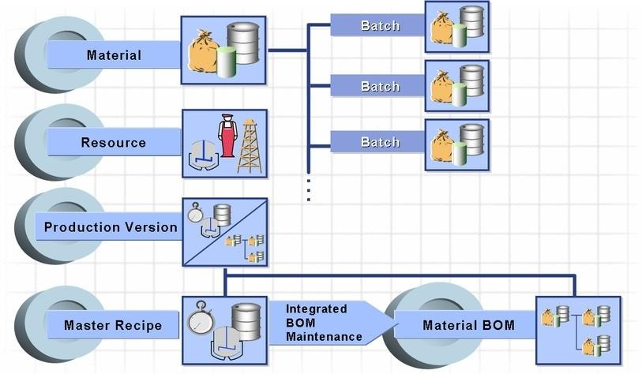

## Material Master

Material Master comprises of all the basic data of the material for each department. The data covers all the relevant information required for the transactional flow, e.g., sales, planning, production of the material. Material Master covers all the descriptive and control data, and the flow of information depend on fields maintained within it. The integration of all material data in a single database object eliminates redundant data storage. Material Masters are created once and can be changed or extended whenever required.

### Material Type

Materials with the same basic attributes are grouped together and assigned to a material type. This allows management of different materials in a uniform manner in accordance with the company's requirements. For manufacturing purposes, the material types used are FERT (Finished Product), HALB (Semi Finished product), ROH (Raw material) and VERP (Packaging material).

The following Material Types are used by Production Planning & Control Dept.:

|  |  |
| --- | --- |
| Material Type | Description |
| Y002 | Red Meat Lamb/Semi |
| Y003 | Red Meat Naked Lamb/Semi |
| Y004 | Red Meat Fresh Cut Ups |
| Y005 | Red Meat Frozen Cut Ups |
| Y006 | Red Meatpacking material |
| Z001 | R& D Raw materials |
| Z002 | R&D Packaging |
| Z003 | R&D Semifinished Product |
| Z004 | R&D Finished Product |
| ZAWA | Arasco -Trading Material |
| ZBAU | Maintenance assemblies |
| ZDIN | IDAC Service |
| ZFIN | Arasco-Finished Material |
| ZIBE | Consumables |
| ZIBU | Maintenance assemblies |
| ZIEQ | Arasco-IT Equipment’s |
| ZMAV | Medicine & Vaccine |
| ZPAK | Arasco-Packing Material |
| ZPIP | MF Pipeline Materials |
| ZROH | Arasco-Raw Material |
| ZSEM | Arasco-Semifinal Material |
| ZSER | Arasco-Service |
| ZSPR | Arasco-Spares Material |
| ZTFG | Repacked Traded |

### Material Views

In SAP, generally the material master fields for PP application are found in the following material master views:

|  |  |  |
| --- | --- | --- |
| View/Screen | Field | Standard |
| MRP 1 | MRP Type  MRP Controller  Lot Size | PD (MRP)  ND (No planning)  VB – Manual reorder point planning; VM – Automatic reorder point planning  100 Raw Material Bul  101 Raw Mat. Non Bul  102 Packaging Materi  103 Chemicals Materi  104 Custom Dairy Fee  105 Live Stock  106 Non Live Stock  109 Pre Mix  110 Archem  111 Processed Grain  200 Spare Inventory  201 Spare Consumable  202 Prod.Consumables  FX (FIXED)  EX (Lot for Lot Order Quantity)  PK( Periodic lot size)  “HB – Replenish to maximum stock level”. |
| MRP 2 | Procurement type  Production Storage Location  Scheduling. Margin Key Safety Stock | E (In-house Prod.)  F (External Proc.)  X (Both Procurement)  000 |
| MRP 3 | Strategy Group  Availability check | 10 (Make to stock)  11 (Gross requirement planning  40 (Planning with final assembly)  50 (Planning without final assembly)  01 Daily requirements  02 Individ.requirements  CH Batches  DR  KP No check  Y2 Daily requirements  Z2 MEFSCO Individ.req. |
| MRP 4 | Selection Method Individual/collective  MRP dep. requirements | (Selection by Production Version)   1. (Daily Requirements) 2. (Individual Requirements) 3. (Dep. Req. are planned) |
| Work Scheduling | Production scheduler | Plant PS Desp  1102 201 DFM Production  1103 301 KFM Production  1104 401 PREMIX  1105 501 ARCHEM  1410 301 KFM Production  1420 201 DFM Production  1420 301 KFM Production  1430 301 KFM Production  1440 301 KFM Production  1450 301 KFM Production  1460 301 KFM Production  1470 301 KFM Production  1471 301 KFM Production  1480 301 KFM Production  1701 201 Corn Cleaning  1701 301 Starch slurry  1701 401 Co-Products Active  1701 501 Starch Bags  1701 601 Glucose Bulk Production  1701 701 Glucose Drums Production  2101 201 DFM Production |

|  |  |  |  |
| --- | --- | --- | --- |
| Plant | Name | PS prof | Profile description |
| 1102 | Dammam Feed Mill | D100 | DFM Feed Bulk |
| 1102 | Dammam Feed Mill | D200 | DFM Feed Bags |
| 1103 | Kharj Feed Mill | F100 | Fish Feed Bulk |
| 1103 | Kharj Feed Mill | F200 | Fish Feed Bags |
| 1103 | Kharj Feed Mill | H100 | Horse & Flaking Feed Bulk |
| 1103 | Kharj Feed Mill | H200 | Horse & Flaking Feed Bags |
| 1103 | Kharj Feed Mill | K100 | KFM Feed Bulk |
| 1103 | Kharj Feed Mill | K200 | KFM Feed Bags |
| 1104 | PREMIX Plant-Kharj | P100 | Pre-Mix Bulk |
| 1104 | PREMIX Plant-Kharj | P200 | Pre-Mix Bags |
| 1105 | ARCHEM plant-Dammam | A100 | ARCHEM Bulk |
| 1105 | ARCHEM plant-Dammam | A200 | ARCHEM Bags |
| 1410 | Food Corporate Plant | F100 | Fish Feed Bulk |
| 1410 | Food Corporate Plant | F200 | Fish Feed Bags |
| 1410 | Food Corporate Plant | H100 | Horse & Flaking Feed Bulk |
| 1410 | Food Corporate Plant | H200 | Horse & Flaking Feed Bags |
| 1410 | Food Corporate Plant | K100 | KFM Feed Bulk |
| 1410 | Food Corporate Plant | K200 | KFM Feed Bags |
| 1420 | Breeder Plant | D100 | DFM Feed Bulk |
| 1420 | Breeder Plant | D200 | DFM Feed Bags |
| 1420 | Breeder Plant | F100 | Fish Feed Bulk |
| 1420 | Breeder Plant | F200 | Fish Feed Bags |
| 1420 | Breeder Plant | H100 | Horse & Flaking Feed Bulk |
| 1420 | Breeder Plant | H200 | Horse & Flaking Feed Bags |
| 1420 | Breeder Plant | K100 | KFM Feed Bulk |
| 1420 | Breeder Plant | K200 | KFM Feed Bags |
| 1430 | Hatchery Plant | F100 | Fish Feed Bulk |
| 1430 | Hatchery Plant | F200 | Fish Feed Bags |
| 1430 | Hatchery Plant | H100 | Horse & Flaking Feed Bulk |
| 1430 | Hatchery Plant | H200 | Horse & Flaking Feed Bags |
| 1430 | Hatchery Plant | K100 | KFM Feed Bulk |
| 1430 | Hatchery Plant | K200 | KFM Feed Bags |
| 1440 | Broiler Plant | F100 | Fish Feed Bulk |
| 1440 | Broiler Plant | F200 | Fish Feed Bags |
| 1440 | Broiler Plant | H100 | Horse & Flaking Feed Bulk |
| 1440 | Broiler Plant | H200 | Horse & Flaking Feed Bags |
| 1440 | Broiler Plant | K100 | KFM Feed Bulk |
| 1440 | Broiler Plant | K200 | KFM Feed Bags |
| 1450 | Poultry Production Plant | F100 | Fish Feed Bulk |
| 1450 | Poultry Production Plant | F200 | Fish Feed Bags |
| 1450 | Poultry Production Plant | H100 | Horse & Flaking Feed Bulk |
| 1450 | Poultry Production Plant | H200 | Horse & Flaking Feed Bags |
| 1450 | Poultry Production Plant | K100 | KFM Feed Bulk |
| 1450 | Poultry Production Plant | K200 | KFM Feed Bags |
| 1460 | Cold Storage Plant | F100 | Fish Feed Bulk |
| 1460 | Cold Storage Plant | F200 | Fish Feed Bags |
| 1460 | Cold Storage Plant | H100 | Horse & Flaking Feed Bulk |
| 1460 | Cold Storage Plant | H200 | Horse & Flaking Feed Bags |
| 1460 | Cold Storage Plant | K100 | KFM Feed Bulk |
| 1460 | Cold Storage Plant | K200 | KFM Feed Bags |
| 1470 | Arasco Food Trading Plan | F100 | Fish Feed Bulk |
| 1470 | Arasco Food Trading Plan | F200 | Fish Feed Bags |
| 1470 | Arasco Food Trading Plan | H100 | Horse & Flaking Feed Bulk |
| 1470 | Arasco Food Trading Plan | H200 | Horse & Flaking Feed Bags |
| 1470 | Arasco Food Trading Plan | K100 | KFM Feed Bulk |
| 1470 | Arasco Food Trading Plan | K200 | KFM Feed Bags |
| 1471 | Further Process Production | F100 | Fish Feed Bulk |
| 1471 | Further Process Production | F200 | Fish Feed Bags |
| 1471 | Further Process Production | H100 | Horse & Flaking Feed Bulk |
| 1471 | Further Process Production | H200 | Horse & Flaking Feed Bags |
| 1471 | Further Process Production | K100 | KFM Feed Bulk |
| 1471 | Further Process Production | K200 | KFM Feed Bags |
| 1480 | Sheep Rearing and Production | F100 | Fish Feed Bulk |
| 1480 | Sheep Rearing and Production | F200 | Fish Feed Bags |
| 1480 | Sheep Rearing and Production | H100 | Horse & Flaking Feed Bulk |
| 1480 | Sheep Rearing and Production | H200 | Horse & Flaking Feed Bags |
| 1480 | Sheep Rearing and Production | K100 | KFM Feed Bulk |
| 1480 | Sheep Rearing and Production | K200 | KFM Feed Bags |
| 1701 | Al Kharj MEFSCO | M100 | Corn Cleaning |
| 1701 | Al Kharj MEFSCO | M200 | Starch Slurry |
| 1701 | Al Kharj MEFSCO | M300 | Co-Products |
| 1701 | Al Kharj MEFSCO | M400 | Starch Bags |
| 1701 | Al Kharj MEFSCO | M500 | Glucose Bulk Semi Finished |
| 1701 | Al Kharj MEFSCO | M600 | Glucose Bulk Finished |
| 1701 | Al Kharj MEFSCO | M700 | Glucose Drums |
| 1701 | Al Kharj MEFSCO | M800 | Re-Work |
| 1701 | Al Kharj MEFSCO | M900 | Re-Packing |
| 2101 | Grains Trading Unit | D200 | DFM Feed Bags |

*Note: Please delete the extra Production schedulers.

* + - 1. Lot-Sizing Procedures

It is material requirements planning's role to generate an order proposal if a requirements shortage is determined during a planning run. The lot size for the order proposal is specified according to the lot-sizing procedure you entered in the material master record.

The SAP System supports the most up-to-date lot-sizing procedures. User-specific formulae can always be integrated with relatively little effort. The available lot-sizing procedures are divided into different groups:

* + - * + 1) Statics Lot Size Procedures
        + 2) Period Lot Size Procedures
        + 3) Optimum Lot Size Procedures

EX (Lot-for-lot order quantity) is the most commonly used, which means lot for lot quantity Which means the lot size is equal to the requirement quantity and it is not be clubbed periodically or for optimum lot size calculations.

FX (Fixed order quantity) is used for Fixed Lot Size and HB (Replenish to maximum stock level) is used as a lot size to replenish stock to the maximum level.

For example – TB (Daily lot size) is used if you want to carry out Daily Lot Sizing; WB (Weekly lot size) is used for Weekly and MB (Monthly lot size) is used for monthly lot size quantity,

|  |  |  |
| --- | --- | --- |
| Lot Size Procedures | Description | Remarks |
| Additional | Minimum and | Minimum Lot Size, system will not consider |
| Calculation | Maximum Lot | order less then given values in one |
| Procedures | Size | Maximum Lot Size, system will not consider |
|  |  | order more than given values in one process |
|  |  | order and more than one production order is |
|  |  | created to handle. |
|  | Lot Size | Rounding the values based on operation |
|  | Rounding | constrain based on the different slap for |
|  | Value | rounding profile, provided by the production |
|  |  | management. |

* + - 1. MRP Type:

MRP Type determines whether and how the material is planned. Fundamentally, materials are planned using the procedure of:

1. Material Requirement Planning
2. Consumption Based Planning.

Material requirements planning would calculate the quantity of each component for the required quantity of these finished products. Whereas, consumption based planning would generate requirements of a material, based on its consumption level.

At ARASCO, all the material types would be MRP type materials i.e., their demand estimation would be pegged with the demand of the finished products and would be triggered via BOM explosions. Please refer to the Material Requirement Planning section for details

* + - 1. MRP Controller:

MRP Controller is the person responsible for planning material or a group of materials in a plant or company. The responsibility would include the replenishment of every material that has been assigned to the controller. This guarantees that sales and manufacturing would be able to perform their functions without any material shortages. Material that takes part in Material Requirements Planning

must be assigned to an MRP controller, according to the planning parameters of each material, e.g., planning horizons, and material type.

|  |  |  |  |
| --- | --- | --- | --- |
| Plant | Plant Name | MRP controller | MRP controller name |
|  |  |  |  |
| 1000 | ARASCO CORPORATE | 100 | Tamkeen Controller |
| 1101 | Port Silo Plant | 100 | Raw Material Bulk |
| 1101 | Port Silo Plant | 101 | Raw Mat. Non Bulk |
| 1101 | Port Silo Plant | 102 | Packaging Material |
| 1101 | Port Silo Plant | 103 | Chemicals Material |
| 1102 | Dammam Feed Mill | 100 | Raw Material Bulk |
| 1102 | Dammam Feed Mill | 101 | Raw Mat. Non Bulk |
| 1102 | Dammam Feed Mill | 102 | Packaging Material |
| 1102 | Dammam Feed Mill | 103 | Chemicals Material |
| 1102 | Dammam Feed Mill | 104 | Custom Dairy Feed |
| 1102 | Dammam Feed Mill | 105 | Live Stock |
| 1102 | Dammam Feed Mill | 106 | Non Live Stock |
| 1102 | Dammam Feed Mill | 109 | Pre-Mix |
| 1102 | Dammam Feed Mill | 110 | Archem |
| 1102 | Dammam Feed Mill | 111 | Processed Grain |
| 1102 | Dammam Feed Mill | 200 | Spare Inventory |
| 1102 | Dammam Feed Mill | 201 | Spare Consumables |
| 1102 | Dammam Feed Mill | 202 | Prod.Consumables |
| 1103 | Kharj Feed Mill | 100 | Raw Material Bulk |
| 1103 | Kharj Feed Mill | 101 | Raw Mat. Non Bulk |
| 1103 | Kharj Feed Mill | 102 | Packaging Material |
| 1103 | Kharj Feed Mill | 103 | Chemicals Material |
| 1103 | Kharj Feed Mill | 104 | Custom Dairy Feed |
| 1103 | Kharj Feed Mill | 105 | Live Stock |
| 1103 | Kharj Feed Mill | 106 | Non Live Stock |
| 1103 | Kharj Feed Mill | 107 | Aqua Feed |
| 1103 | Kharj Feed Mill | 108 | Miscellaneous Feed |
| 1103 | Kharj Feed Mill | 109 | Pre-Mix |
| 1103 | Kharj Feed Mill | 110 | Archem |
| 1103 | Kharj Feed Mill | 111 | Processed Grain |
| 1103 | Kharj Feed Mill | 300 | Spare Inventory |
| 1103 | Kharj Feed Mill | 301 | Spare Consumables |
| 1103 | Kharj Feed Mill | 302 | Prod.Consumables |
| 1104 | PREMIX Plant-Kharj | 100 | Raw Material Bulk |
| 1104 | PREMIX Plant-Kharj | 101 | Raw Mat. Non Bulk |
| 1104 | PREMIX Plant-Kharj | 102 | Packaging Material |
| 1104 | PREMIX Plant-Kharj | 103 | Chemicals Material |
| 1104 | PREMIX Plant-Kharj | 109 | Pre-Mix |
| 1104 | PREMIX Plant-Kharj | 110 | Archem |
| 1104 | PREMIX Plant-Kharj | 112 | Phantom Pre Mix |
| 1105 | ARCHEM plant-Dammam | 100 | Raw Material Bulk |
| 1105 | ARCHEM plant-Dammam | 101 | Raw Mat. Non Bulk |
| 1105 | ARCHEM plant-Dammam | 102 | Packaging Material |
| 1105 | ARCHEM plant-Dammam | 103 | Chemicals Material |
| 1105 | ARCHEM plant-Dammam | 110 | Archem |
| 1201 | BHP | 200 | Engineering Item |
| 1201 | BHP | 300 | Spare planning |
| 1202 | Logistics Transportation | 200 | Engineering Item |
| 1202 | Logistics Transportation | 300 | Spare planning |
| 1203 | Logistics Foods Transportation | 200 | Engineering Item |
| 1203 | Logistics Foods Transportation | 300 | Spare planning |
| 1204 | Material Management Department | 200 | Engineering Item |
| 1204 | Material Management Department | 300 | Spare planning |
| 1204 | Material Management Department | 301 | Consumables |
| 1410 | Food Corporate Plant | 100 | Raw Material Bulk |
| 1410 | Food Corporate Plant | 101 | Raw Mat. Non Bulk |
| 1410 | Food Corporate Plant | 102 | Packaging Material |
| 1410 | Food Corporate Plant | 103 | Chemicals Material |
| 1410 | Food Corporate Plant | 104 | Custom Dairy Feed |
| 1410 | Food Corporate Plant | 105 | Live Stock |
| 1410 | Food Corporate Plant | 106 | Non Live Stock |
| 1410 | Food Corporate Plant | 107 | Aqua Feed |
| 1410 | Food Corporate Plant | 108 | Miscellaneous Feed |
| 1410 | Food Corporate Plant | 109 | Pre-Mix |
| 1410 | Food Corporate Plant | 110 | Archem |
| 1410 | Food Corporate Plant | 111 | Processed Grain |
| 1410 | Food Corporate Plant | 999 | Old Material |
| 1420 | Breeder Plant | 100 | Raw Material Bulk |
| 1420 | Breeder Plant | 101 | Raw Mat. Non Bulk |
| 1420 | Breeder Plant | 102 | Packaging Material |
| 1420 | Breeder Plant | 103 | Chemicals Material |
| 1420 | Breeder Plant | 104 | Custom Dairy Feed |
| 1420 | Breeder Plant | 105 | Live Stock |
| 1420 | Breeder Plant | 106 | Non Live Stock |
| 1420 | Breeder Plant | 107 | Aqua Feed |
| 1420 | Breeder Plant | 108 | Miscellaneous Feed |
| 1420 | Breeder Plant | 109 | Pre-Mix |
| 1420 | Breeder Plant | 110 | Archem |
| 1420 | Breeder Plant | 111 | Processed Grain |
| 1420 | Breeder Plant | 200 | Spare planning |
| 1420 | Breeder Plant | 999 | Old Material |
| 1430 | Hatchery Plant | 100 | Raw Material Bulk |
| 1430 | Hatchery Plant | 101 | Raw Mat. Non Bulk |
| 1430 | Hatchery Plant | 102 | Packaging Material |
| 1430 | Hatchery Plant | 103 | Chemicals Material |
| 1430 | Hatchery Plant | 104 | Custom Dairy Feed |
| 1430 | Hatchery Plant | 105 | Live Stock |
| 1430 | Hatchery Plant | 106 | Non Live Stock |
| 1430 | Hatchery Plant | 107 | Aqua Feed |
| 1430 | Hatchery Plant | 108 | Miscellaneous Feed |
| 1430 | Hatchery Plant | 109 | Pre-Mix |
| 1430 | Hatchery Plant | 110 | Archem |
| 1430 | Hatchery Plant | 111 | Processed Grain |
| 1430 | Hatchery Plant | 999 | Old Material |
| 1430 | Hatchery Plant | Z01 | Chemicals |
| 1430 | Hatchery Plant | Z04 | Consumables |
| 1440 | Broiler Plant | 100 | Raw Material Bulk |
| 1440 | Broiler Plant | 101 | Raw Mat. Non Bulk |
| 1440 | Broiler Plant | 102 | Packaging Material |
| 1440 | Broiler Plant | 103 | Chemicals Material |
| 1440 | Broiler Plant | 104 | Custom Dairy Feed |
| 1440 | Broiler Plant | 105 | Live Stock |
| 1440 | Broiler Plant | 106 | Non Live Stock |
| 1440 | Broiler Plant | 107 | Aqua Feed |
| 1440 | Broiler Plant | 108 | Miscellaneous Feed |
| 1440 | Broiler Plant | 109 | Pre-Mix |
| 1440 | Broiler Plant | 110 | Archem |
| 1440 | Broiler Plant | 111 | Processed Grain |
| 1440 | Broiler Plant | 999 | Old Material |
| 1440 | Broiler Plant | Z01 | Chemicals |
| 1440 | Broiler Plant | Z04 | Consumables |
| 1450 | Poultry Production Plant | 100 | Raw Material Bulk |
| 1450 | Poultry Production Plant | 101 | Raw Mat. Non Bulk |
| 1450 | Poultry Production Plant | 102 | Packaging Material |
| 1450 | Poultry Production Plant | 103 | Chemicals Material |
| 1450 | Poultry Production Plant | 104 | Custom Dairy Feed |
| 1450 | Poultry Production Plant | 105 | Live Stock |
| 1450 | Poultry Production Plant | 106 | Non Live Stock |
| 1450 | Poultry Production Plant | 107 | Aqua Feed |
| 1450 | Poultry Production Plant | 108 | Miscellaneous Feed |
| 1450 | Poultry Production Plant | 109 | Pre-Mix |
| 1450 | Poultry Production Plant | 110 | Archem |
| 1450 | Poultry Production Plant | 111 | Processed Grain |
| 1450 | Poultry Production Plant | 999 | Old Material |
| 1450 | Poultry Production Plant | Z01 | Chemicals |
| 1450 | Poultry Production Plant | Z02 | Marinated Items |
| 1450 | Poultry Production Plant | Z03 | Packaging Material |
| 1450 | Poultry Production Plant | Z04 | Prod.Consumables |
| 1450 | Poultry Production Plant | Z05 | FOOD Spares Invent |
| 1450 | Poultry Production Plant | Z06 | FOOD Spares Consum |
| 1460 | Cold Storage Plant | 100 | Raw Material Bulk |
| 1460 | Cold Storage Plant | 101 | Raw Mat. Non Bulk |
| 1460 | Cold Storage Plant | 102 | Packaging Material |
| 1460 | Cold Storage Plant | 103 | Chemicals Material |
| 1460 | Cold Storage Plant | 104 | Custom Dairy Feed |
| 1460 | Cold Storage Plant | 105 | Live Stock |
| 1460 | Cold Storage Plant | 106 | Non Live Stock |
| 1460 | Cold Storage Plant | 107 | Aqua Feed |
| 1460 | Cold Storage Plant | 108 | Miscellaneous Feed |
| 1460 | Cold Storage Plant | 109 | Pre-Mix |
| 1460 | Cold Storage Plant | 110 | Archem |
| 1460 | Cold Storage Plant | 111 | Processed Grain |
| 1460 | Cold Storage Plant | 999 | Old Material |
| 1460 | Cold Storage Plant | Z01 | Chemicals |
| 1460 | Cold Storage Plant | Z02 | Marinated Items |
| 1460 | Cold Storage Plant | Z03 | Packaging Material |
| 1460 | Cold Storage Plant | Z04 | Consumables |
| 1470 | Arasco Food Trading Plan | 100 | Raw Material Bulk |
| 1470 | Arasco Food Trading Plan | 101 | Raw Mat. Non Bulk |
| 1470 | Arasco Food Trading Plan | 102 | Packaging Material |
| 1470 | Arasco Food Trading Plan | 103 | Chemicals Material |
| 1470 | Arasco Food Trading Plan | 104 | Custom Dairy Feed |
| 1470 | Arasco Food Trading Plan | 105 | Live Stock |
| 1470 | Arasco Food Trading Plan | 106 | Non Live Stock |
| 1470 | Arasco Food Trading Plan | 107 | Aqua Feed |
| 1470 | Arasco Food Trading Plan | 108 | Miscellaneous Feed |
| 1470 | Arasco Food Trading Plan | 109 | Pre-Mix |
| 1470 | Arasco Food Trading Plan | 110 | Archem |
| 1470 | Arasco Food Trading Plan | 111 | Processed Grain |
| 1470 | Arasco Food Trading Plan | 999 | Old Material |
| 1471 | Further Process Production | 100 | Raw Material Bulk |
| 1471 | Further Process Production | 101 | Raw Mat. Non Bulk |
| 1471 | Further Process Production | 102 | Packaging Material |
| 1471 | Further Process Production | 103 | Chemicals Material |
| 1471 | Further Process Production | 104 | Custom Dairy Feed |
| 1471 | Further Process Production | 105 | Live Stock |
| 1471 | Further Process Production | 106 | Non Live Stock |
| 1471 | Further Process Production | 107 | Aqua Feed |
| 1471 | Further Process Production | 108 | Miscellaneous Feed |
| 1471 | Further Process Production | 109 | Pre-Mix |
| 1471 | Further Process Production | 110 | Archem |
| 1471 | Further Process Production | 111 | Processed Grain |
| 1471 | Further Process Production | 999 | Old Material |
| 1480 | Sheep Rearing and Production | 100 | Raw Material Bulk |
| 1480 | Sheep Rearing and Production | 101 | Raw Mat. Non Bulk |
| 1480 | Sheep Rearing and Production | 102 | Packaging Material |
| 1480 | Sheep Rearing and Production | 103 | Chemicals Material |
| 1480 | Sheep Rearing and Production | 104 | Custom Dairy Feed |
| 1480 | Sheep Rearing and Production | 105 | Live Stock |
| 1480 | Sheep Rearing and Production | 106 | Non Live Stock |
| 1480 | Sheep Rearing and Production | 107 | Aqua Feed |
| 1480 | Sheep Rearing and Production | 108 | Miscellaneous Feed |
| 1480 | Sheep Rearing and Production | 109 | Pre-Mix |
| 1480 | Sheep Rearing and Production | 110 | Archem |
| 1480 | Sheep Rearing and Production | 111 | Processed Grain |
| 1480 | Sheep Rearing and Production | 999 | Old Material |
| 1501 | IDAC Mérieux NutriSciences | 150 | IDAC Spare Materia |
| 1501 | IDAC Mérieux NutriSciences | 151 | IDAC Consumables |
| 1501 | IDAC Mérieux NutriSciences | 152 | IDAC Raw Materials |
| 1600 | Central Warehouse | 600 | Argo Material |
| 1600 | Central Warehouse | 601 | Vet Material |
| 1601 | Head Office | 600 | Argo Material |
| 1601 | Head Office | 601 | Vet Material |
| 1602 | Riyadh Branch | 600 | Argo Material |
| 1602 | Riyadh Branch | 601 | Vet Material |
| 1603 | Al-Kharj Branch | 600 | Argo Material |
| 1603 | Al-Kharj Branch | 601 | Vet Material |
| 1604 | Dammam Branch | 600 | Argo Material |
| 1604 | Dammam Branch | 601 | Vet Material |
| 1605 | Wadi Al-Dawasir Branch | 600 | Agro Material |
| 1605 | Wadi Al-Dawasir Branch | 601 | Vet Material |
| 1606 | Sajar Branch | 600 | Agro Material |
| 1606 | Sajar Branch | 601 | Vet Material |
| 1607 | Al-Qassim Branch | 600 | Agro Material |
| 1607 | Al-Qassim Branch | 601 | Vet Material |
| 1608 | Hail Branch | 600 | Agro Material |
| 1608 | Hail Branch | 601 | Vet Material |
| 1609 | Al-Jouf Branch | 600 | Agro Material |
| 1609 | Al-Jouf Branch | 601 | Vet Material |
| 1610 | Tabuk Branch | 600 | Agro Material |
| 1610 | Tabuk Branch | 601 | Vet Material |
| 1611 | Jeddah Branch | 600 | Agro Material |
| 1611 | Jeddah Branch | 601 | Vet Material |
| 1612 | Najaran Branch | 600 | Agro Material |
| 1612 | Najaran Branch | 601 | Vet Material |
| 1613 | Khamis Musayat Branch | 600 | Agro Material |
| 1613 | Khamis Musayat Branch | 601 | Vet Material |
| 1701 | Al Kharj MEFSCO | 700 | Starch Slurry |
| 1701 | Al Kharj MEFSCO | 701 | Glucose |
| 1701 | Al Kharj MEFSCO | 702 | Starch |
| 1701 | Al Kharj MEFSCO | 703 | Raw Materials |
| 1701 | Al Kharj MEFSCO | 704 | Packaging Material |
| 1701 | Al Kharj MEFSCO | 711 | MF_Spare Materials |
| 1701 | Al Kharj MEFSCO | 712 | MF_Consumables |
| 2101 | Grains Trading Unit | 100 | Raw Material Bulk |
| 2101 | Grains Trading Unit | 101 | Raw Mat. Non Bulk |
| 2101 | Grains Trading Unit | 102 | Packaging Material |
| 2101 | Grains Trading Unit | 103 | Chemicals Material |
| 2101 | Grains Trading Unit | 104 | Custom Dairy Feed |
| 2101 | Grains Trading Unit | 105 | Live Stock |
| 2101 | Grains Trading Unit | 106 | Non Live Stock |
| 2101 | Grains Trading Unit | 109 | Pre-Mix |
| 2101 | Grains Trading Unit | 110 | Archem |
| 2101 | Grains Trading Unit | 111 | Processed Grain |
| 2101 | Grains Trading Unit | 200 | Spare planning |
| 2101 | Grains Trading Unit | 999 | Old Material |
| 2202 | ASG Aqua Plant | 600 | Agro Material |
| 2202 | ASG Aqua Plant | 601 | Vet Material |

*Note:- Some of the MRP controller are not being used for a long time the same can be deleted

* + - 1. Procurement Type:

Procurement Type defines how the material is procured. The following procurement types are possible:

* + - * + The material is produced in-house.
        + The material is procured externally.
        + The material can be both produced in-house and procured externally.

At ARASCO, procurement types will be as follows,

|  |  |  |
| --- | --- | --- |
| Material Type | Procurement Type | |
| Type | Description |
| Finished material | X | In house production |
| Semi-finished  material | X | In house production |

* + - 1. Production Storage Location

In case of a material produced in-house, it is the receiving storage location to which the receipt of the material is posted.

If the material is a component, it is the issuing storage location from which the material issuance is posted.

Please refer to MM BBP for production storage locations at ARASCO.

Production Storage location is not defined for several materials, So the production storage location should be defined for all the FG, SFG and Raw material in manufacturing plants.

* + - 1. Safety Stock

Safety stock specifies the quantity to satisfy unexpectedly high demand in the coverage period. It reduces the risk of shortfalls in case of fluctuation in the demand. Safety stocks are maintained in terms of quantity in the material master record.

At ARASCO, Dynamic Safety stock will be maintained mostly for finished materials. The stock radius would be defined as per company policy for all the materials for which ARASCO would keep safety stocks

* + - 1. Strategy Group

The grouping of all the planning strategies that can be used for a particular material is a Strategy Group. The planning strategy represents the procedure used for planning a material, e.g., make-to-stock strategy or make-to-order strategy.

At ARASCO, Make-to Stock strategy would be used.

|  |  |
| --- | --- |
| Strategy Group | Description |
| 40 | Make-to-stock production – Planning with final assembly |
| 10 | Make-to-stock production |
| 50 | Make-to-order ( Planning without final assembly) |
| 11 | Gross requirement planning |

* + - 1. Availability Check

A procedure that ensures that there are enough components available for planned or production orders in production planning and production control.

|  |  |
| --- | --- |
| Availability check | Description |
| 01 | Daily requirements |
| 02 | Individ.requirements |
| CH | Batches |
| KP | No check |
| Y2 | Daily requirements |
| Z2 | MEFSCO Individ.req. |

* + - 1. Production Scheduler

Production Scheduler would be responsible for activities in production control for a material. At ARASCO, Production Scheduler as mention below.

|  |  |  |
| --- | --- | --- |
| Plant | Production Scheduler | Description |
| 1102 | 201 | DFM Production |
| 1103 | 301 | KFM Production |
| 1104 | 401 | PREMIX Production |
| 1105 | 501 | ARCHEM Production |
| 1410 | 301 | KFM Production |
| 1420 | 201 | DFM Production |
| 1420 | 301 | KFM Production |
| 1430 | 301 | KFM Production |
| 1440 | 301 | KFM Production |
| 1450 | 301 | KFM Production |
| 1460 | 301 | KFM Production |
| 1470 | 301 | KFM Production |
| 1471 | 301 | KFM Production |
| 1480 | 301 | KFM Production |
| 1701 | 201 | Corn Cleaning Production |
| 1701 | 301 | Starch slurry Production |
| 1701 | 401 | Co-Products |
| 1701 | 501 | Starch Bags |
| 1701 | 601 | Glucose Bulk Production |
| 1701 | 701 | Glucose Drums Production |
| 2101 | 201 | DFM Production |

*Note:- Some of the Production Scheduler are not being used for a long time the same can be deleted

* + - 1. Batch Management

It is a key functional area of SAP that manages batches throughout the entire enterprise, from vendor receipt through distribution, with full traceability.

Batch Determination configuration is required for FIFO based goods issue & expiry date management.

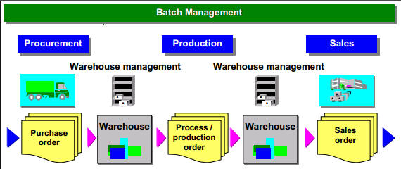

Batch Management should be activated for all finished materials and Semi finished material as mentioned in below table.

|  |  |  |
| --- | --- | --- |
| Material Type | Description | Batch Management |
| Y002 | Red Meat Lamb/Semi | Yes |
| Y003 | Red Meat Naked Lamb/Semi | Yes |
| Y004 | Red Meat Fresh Cut Ups | Yes |
| Y005 | Red Meat Frozen Cut Ups | Yes |
| Y006 | Red Meatpacking material | No |
| Z001 | R& D Raw materials | No |
| Z002 | R&D Packaging | No |
| Z003 | R&D Semifinished Product | Yes |
| Z004 | R&D Finished Product | Yes |
| ZAWA | Arasco -Trading Material | No |
| ZBAU | Maintenance assemblies | No |
| ZDIN | IDAC Service | No |
| ZFIN | Arasco-Finished Material | Yes |
| ZIBE | Consumables | No |
| ZIBU | Maintenance assemblies | No |
| ZIEQ | Arasco-IT Equipment’s | No |
| ZMAV | Medicine & Vaccine | Yes |
| ZPAK | Arasco-Packing Material | No |
| ZPIP | MF Pipeline Materials | No |
| ZROH | Arasco-Raw Material | No |
| ZSEM | Arasco-Semifin Material | Yes |
| ZSER | Arasco-Service | No |
| ZSPR | Arasco-Spares Material | No |
| ZTFG | Repacked Traded | No |

## Bill of Material (BNK)

In ARASCO 2148 BOMs are created in SAP

Bill of Materials or commonly called BOM is a formally structured list of components that make up a product or assembly. The list contains the material number of the component together with the quantity and unit of measure.

BOMs are used in their different forms in various situations where a finished product is assembled from several component parts or materials. Depending on the industry sector, they can also be called recipes or lists of ingredient and so on.

This product structure (BOM) is maintained in SAP and serves as the basis for the following activities:

* + - For material requirement planning
    - Creating material reservations
    - Availability checks of materials
    - For product costing

Production planning and costing requires that a Bill of Materials is in place to support the product being manufactured. Furthermore, product costing requires the definition of the BOM as a quantitative recipe.

MRP uses BOM’s as its basis; these define the relationships of assemblies (finished products) and their components (Semi-finished and raw materials). BOM acquired a new function with MRP, becoming a framework on which, the entire planning process depends. As a vital part of MRP, BOM must be accurate and up to date for its output to be valid.

All levels of BOM shall be incorporated in the SAP with their respective bill of material along with their sub-assemblies. Alternative BOM’s will be maintained for the assemblies

Co-Product: Co-product is a product, we getting this product while manufacturing finished material or main material. Same material might be used in other material manufacturing process

By-product By-product is a product, we getting this product while manufacturing finished material or main material.  The material valuation of a by-product is always based on the price specified by price control in the material master.

*Note:- Feed:-

At present Brill is integrated to plant 1102 and 1103, for 1104 there is not integration.

While creating BOM the following data is taken into consideration:

### Information Required for BOM

|  |  |
| --- | --- |
| Information Required | Descriptions |
| Material  Number | Finished or Semi-Finished product whose BOM is to be created. |
| Plant | Plant, to which the BOM belongs. |
| Base Quantity | Quantity to which all component quantities in a BOM relate. |
| Components | The list of materials required for manufacturing a product. |
| Component  Quantity | Quantity required for producing the base quantity of Finished  Product. |

### Creation of BOM Process Flow



Display Bill of Material

Change Bill of Material

Create Bill of Material

Production Department

S/4 HANA

## Resource (BNJ)



**Resource**

**Default values**

**Costing**

**Sched. Data Capacity Data**

**Costing**

**Scheduling & Capacity**

**1010,-**

**2150, 3160,-**

**Master Recipe**

In ARASCO 122 Resources are created in SAP

Resources are production facilities and persons involved in a production process that have capacities. They are subdivided into categories to specify their suitability for certain purposes or their use in certain processes.

Resource can be, for example:

* + - Parts of the plant that are used for production (processing units)
    - A group of people are also considered as resource (packing resource)

The data in the Resource are used, for example, for:

### Scheduling

Operating times and formulas for calculating the operation duration are maintained in the Resource.

### Costing

Formulas for calculating the operation costs are maintained in the Resource. In addition, a Resource is assigned to a cost center.

### Capacity Requirement Planning

Formulas for calculating capacity requirements for an operation are maintained in Resource.

### Information Required for Resource

While creating Resources the following data is given:

|  |  |
| --- | --- |
| Information  Required | Descriptions |
| Resource  Number | Number that identifies a Resource |
| Plant | Plant, in which the Resource belongs |
| Resource Category | Key which distinguishes the Resource by their category (for example labor and Processing Line) |
| Capacity | Capacities assigned refer the number of hours a Resource is available for production, along with the formulas of calculating the  capacity requirement in that Resource. |
| Scheduling | A capacity is used to calculates the start and finish dates of an operation |
| Costing | Assignment of Cost Center and its activity types to calculate the  cost of every activity in a Resource. |

* + - 1. Basic Data

In the Basic data screen various administrative data is entered, such as the person responsible and the location of the Resource.

|  |  |
| --- | --- |
| Standard value key | Description |
| ZFD1 | FOOD PRODUCTION |
| ZMEF | MEFSCO Production |
| ZSAP | ARASCO Production |

The Standard Parameters are:

|  |  |  |
| --- | --- | --- |
| **Standard Key Value** | **Formula** | **Description** |
| **ZSAP** | **SAP007** | **Labor Fixed Costs** |
| **SAP006** | **Machine** |
| **ZPKG** | **Factory Overhead** |
| **SAP006** | **Energy Steam** |
| **SAP006** | **Energy Electricity** |
| ZMEF | **DEP01** | **Processing Time** |
| **FLBR01** | **Labor Fixed Costs** |
| **VLBR01** | **Labor Variable Costs** |
| **FOVH01** | **Factory OH Fixed** |
| **VOVH01** | **Factory OH Variable** |
| ZFD1 | **MCH01** | **Processing Time** |
| LBR01 | Labor Fixed Costs |
|  | Factory OH Fixed |

Key for task list usage:

Key to control in which type of task list you can use: operating resources (for example, work centers or production resources/tools).

Back flushing:

Due to variable production parameters Backflush is not used extensively.

Some material component is allocated to an operation in the process order. If a material component is back flushed, the system automatically posts the withdrawal when the operation is confirmed.

* + - 1. Default Values

The default values for operation and in Resource are entered. The default values are then copied when the Resource is assigned to the operation.

|  |  |  |
| --- | --- | --- |
| Control Key | Plant | Control Key Description. |
| PI01 | 1000 | Process manufacturing |
| PI03 | 1000 | Process manuf. with autom. goods |

By entering default values, it reduces the effort necessary in editing operations, since the values are stored centrally and need not be entered them in each operation.

* + - 1. Capacity

Capacity is the ability to perform a specific task. It is defined in terms of machine hours or production hours. Capacities can be entered and changed in resources as well as independently.

Various capacities are distinguished in a Resource, such as labor or machines, by using the capacity category. In order to plan capacities in a more detailed manner, individual capacities can be defined for each capacity. For example, a group of machines is defined as one Resource, which has the number of machines as its individual capacities.

The following data is entered in a capacity:

* + - * + The operating time
        + The available capacity
        + Formulas for calculating capacity requirements

Formulas for calculating capacity requirements for an operation are maintained in resources.

* + - 1. Scheduling

Scheduling is used to calculate the duration of an operation. Scheduling formulas are defined in the Resource to calculate the execution times of operations in production orders using standard values given in the Recipe.

At ARASCO, scheduling will be defined for each Resource at plant level.

* + - 1. Costing

Costing data has to be maintained in order to cost the activities performed at the Resources. In this case a Cost Centre has to be assigned in the Resource and activity types and costing formulas have to be defined.

At ARASCO, the costs are monitored for each Resource. For this purpose, a Cost Centre will be defined in the Resource.

Operations are carried out at a Resource. In the SAP system, Resource are business objects that can represent the following real Resource, for example:

* + - * + A processing unit
        + A person (such as a process operator)

### Creation of Resource Process Flow



Display Resource

Change Resource

Create Resource

Production Department

S/4 HANA

## Master Recipe (BNL)

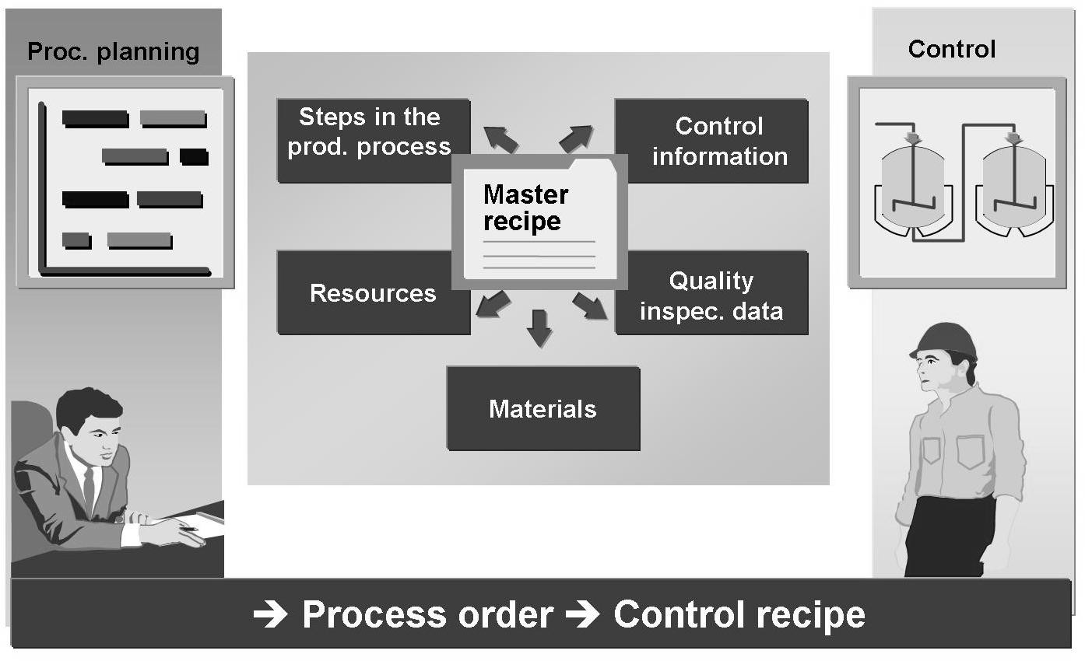

The business object master recipe is the description of an enterprise-specific process in process industries, that does not relate to a specific order. The master recipe is used for the manufacture of products or for rendering services.

A master recipe defines the following data that is required for the production of materials without relating to a particular order: processing steps, resources, material components, data for quality inspection during production.

A master recipe is a description of which operations (process steps) have to be carried out and in which order to produce a material (product). As well as information about the operations and the order in which they are carried out, a master recipe also contains details of the Resource at which they are carried out.

Standard values that have been defined in a Resource are maintained for the execution of each Resource as an individual operation, by having the number of hours required in producing a certain quantity. All data in the master recipe would be the basis of a Process Order.

The followings are planned in a master recipe:

* + - The operations (work steps) to be carried out during production
    - The activities involved in the operations as a basis for determining dates, capacity requirements and costs.
    - The use of materials during production
    - The use of Resources.

### Information Required for Master Recipe

While defining Recipe following are the key inputs required:

|  |  |
| --- | --- |
| Information  Required | Descriptions |
| Material  Number | Finished or Semi-Finished product whose Recipe is to be  created. |
| Plant | Plant, in which the Recipe of the material belongs. |
| Operations | Sequence of operations involved turning components in to  Finished Product. |
| Resource | Resources, where the production is carried out. |
| Material  Assignment (BOM) | Materials defined in BOM’s are assigned to the header data of Recipe. |
| Component  Allocation | Components of the material header are assigned to their  respective operations. |
| Processing  Time | Time required to be completed the operation. |

At ARASCO, master recipe will be created for all the finished and semi-finished materials. These master recipes will be used in capacity loading, scheduling and costing purposes.

All the raw materials will be allocated to operations and after confirmation or completion of certain operations the process order will be completed.

Master Recipe enable to plan the production of materials (products). Therefore, master recipe are used as a template for process orders and run schedules as well as a basis for product costing. In a master recipe:

* + - * The operations (work steps) to be carried out during production
      * The activities to be performed in the operations as a basis for determining dates, capacity requirements, and costs
      * The use of materials during production
      * The use of Resources

### Creation of Recipe Process Flow



Display Recipe

Change Recipe

Create Recipe

Production Department

S/4 HANA

## Production Version

A production version determines which alternative BOM is used together with which task list/master recipe to produce a material or create a master production schedule.

For one material, there can be several production versions for various validity periods and lot-size ranges.

The production version determines the following:

* + - The BOM alternative for a BOM explosion.
    - The Master Recipe and any alternate, as needed.
    - Lot-size restrictions and validity parameters.
    - For each product, there will be one production version.
    - Lot size and validity date will same for every production of material.
    - Locked and not locked

## Factory Calendar and Planning Calendar

The factory calendar is defined on the basis of a public holiday calendar. The validity period of a factory calendar must be within the validity period of the public holiday calendar. The public holiday and factory calendar is a central module in the SAP System. It is assigned to a specific plant during the initial system setup and therefore used in many areas (e.g., in Logistics) in the system.

The weekdays that are working days must also be specified in this calendar.

**Requirement**

* + - Sunday through Thursday are working days.
    - Friday and Saturday are non-working days.

Proposed settings for factory calendar, which will be configured in the system as per below:

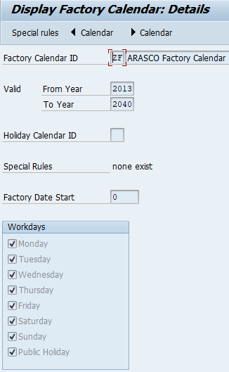

|  |  |  |
| --- | --- | --- |
| Setting | Values | Remarks |
| Define public holidays |  |  |
| Define public holiday calendar | ID: ARASCO  Desc: Holiday calendar – ARASCO | All days in year are working days except Saturday, Sunday and Public Holidays |
| Define factory calendar | ID: ARASCO  Desc: Factory calendar - ARASCO |  |
| Assignment to Plant |  | Linking of factory calendar to plant. |

Planning Calendar

D01:- Damam Factory calendar

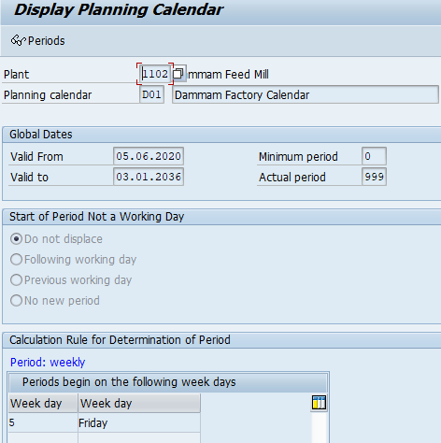

K01 :KFM 1103

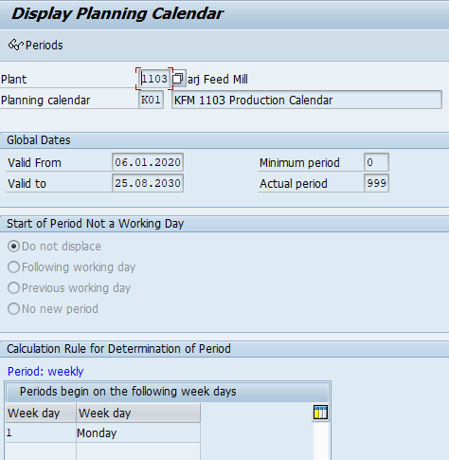

# Overall Process flow for MRP

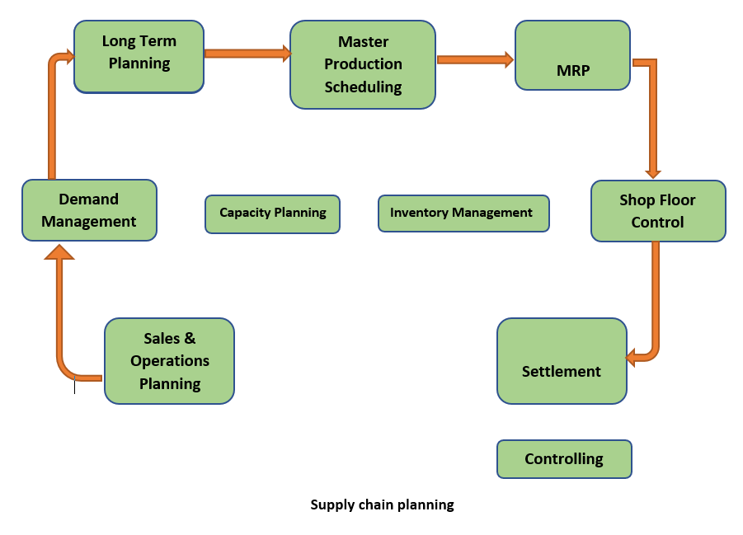.

# Sales and Operation Planning

The Sales and Operation Planning (SOP) component in SAP manages sales, production, and other supply chain targets of the organization. This is done through a planning tool that uses historical and current data to set up the future supply chain targets in the system.

Information passed through sales and operations planning is passed into Master Production Scheduling (MPS) and Material Requirement Planning (MRP). SOP is also connected with profitability analysis, cost center accounting, and activity-based costing. There are two main planning methods available in SOP and we can customize further methods based on the requirement

1. Consistent planning
2. Level-by-level planning
3. Delta planning

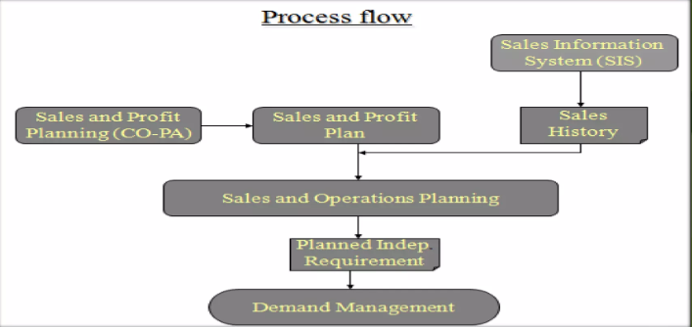

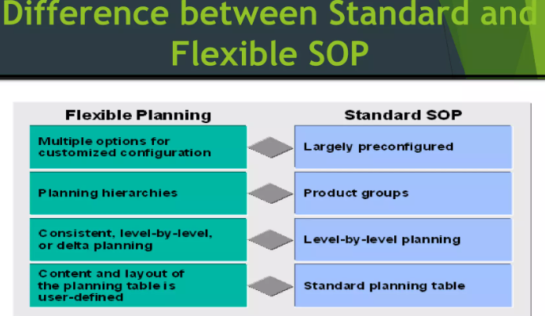

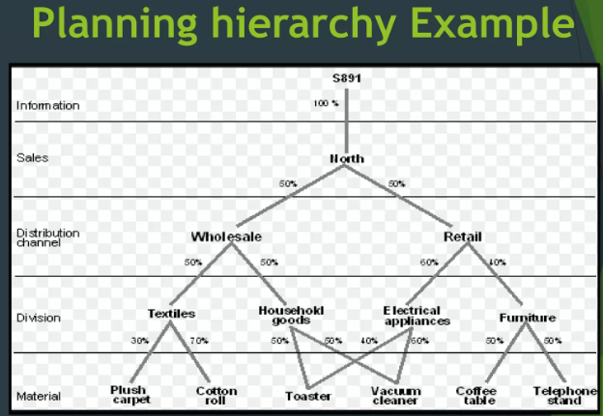

* 1. Standard SOP

Creation of Product Group

Create plan in inactive version

Disaggregate product group plan

Convert inactive to active version

Transfer SOP Plan to Demand management

* 1. Flexible SOP

Create info Structure

Activate the info structure

Assign the planning parameters to the info structure

Creation of planning Hierarchy

Creation planning type and Macros

Calculate proportion factors

Planning in the planning table

Copy planning version

Transfer planning data to demand management.

# Demand Management

Demand management in production planning is handled through the planning strategy. Planning strategy determines the method in which a product is manufactured. The main demand management method is planned independent requirements (PIR). The PIR creates demand in the system, and it can be used in a make-to-stock (MTS) planning strategy.

The MTS is a planning strategy where the production is done without any relationship to a sales order. Manufactured components will be stocked in a warehouse and when the customer demand arises, the stock will be issued against a sales order. Two planning strategies are mainly used in an MTS scenario. The first is strategy is **10**, which only considers the PIR quantity. The second strategy is **40**, which considers both PIR and sales orders. When sales orders are raised, PIR quantity is reduced during the MRP run.

A make-to-order (MTO) planning strategy **20** is based on sales orders. Production does not start until the customer sales orders are placed in the system. Production and inventory are managed with the sales order link and the production process can be tracked using the sales order.

# Long Term Planning

Long-term planning is used to check the future demands of materials based on the bill of material (BOM). Long-term planning can be carried out in simulation mode. It will check the capacity availabilities, material forecast, and delivery timelines, and if the requirements can be fulfilled, simulation can be transferred into an operational mode.

Long-term planning can be executed based on an existing production BOM. It is also possible to define BOM and Recipe specifically for long-term planning.

# Master Production Scheduling

Master production scheduling (MPS) enables the planning of critical materials of an organization with special tools. MPS increases material availability, reduces storage costs, and increases planning stability. MPS materials are planned independently and will not be considered in the regular MRP runs.

# Material Requirement Planning

Material requirement planning (MRP) is the heart of the production planning process. MRP matches the demand and the supply and proposes the best methods for executing the production process. The output of the MRP run is the procurement proposals.

There are two main procurement proposals in SAP. These are the plan order and purchase requisitions.

Plan order is generated through MRP for materials that are produced in-house. Plan orders are converted into production orders when the manufacturing starts. The second procurement proposal which MRP generates is the purchase requisitions. Purchase requisitions are generated for materials that are procured from external parties. These include mainly the raw materials. Purchase requisitions are converted into purchase orders.

When the MRP is executed, the BOM will be exploded. Based on the planning strategy of the materials, a procurement proposal will be generated. There are three processing keys used for MRP.

1. **NETCH** – net change planning considers materials that have undergone an MRP relevant change after the last MRP run. An example of MRP relevant change is the increase of stock in the system.
2. **NETPL** – net change in the planning horizon is similar to NETCH but it works for a defined planning period.

# Re-order point planning

SAP Consumption Based Planning (or CBP) has procedures that are based on information about previous material consumption or the historical data. The [MRP procedures](https://erproof.com/mm/free-training/sap-mrp-procedures/) that come under consumption based planning are:

* Reorder point planning
* Forecast-based planning
* Time-phased planning

The material requirements planning takes place at plant level. The entire stock on the plant is considered for planning irrespective of storage locations. we will discuss SAP reorder point planning. The reorder point planning consists of two procedures:

1. Manual reorder point
2. Automatic reorder point planning

In SAP reorder point planning, a reorder point is obtained by calculating a sum of plant stock and firmed receipts. When the stock level falls below the reorder point, a procurement proposal is triggered. The following parameters are important when considering the reorder point:

* safety stock
* average consumption
* replenishment lead time

In manual reorder point planning, both the reorder point and safety stock are maintained manually in the MRP 1 view of a [material master record](https://erproof.com/mm/free-training/sap-mm-material-master/). In automatic reorder point planning, the reorder level and safety stock are calculated automatically by the forecasting program.

# PROCESS ORDER MANAGEMENT

Master data by definition is data that remains unchanged over an extended period of time. Master data contains information that is always used in the same way. The Master Data in Production Planning module for Process Manufacturing are as follows: Process execution process is used to convert the raw materials into the finished and semi-finished products. The Process Order Management process can be sub-divided into three major areas:

* Process planning
* Process order execution/process management
* Order closing

## Process planning

It comprises all activities that are performed during the creation and release of a process order. Important steps in process planning are:

* + 1. Process Order creation

A process order describes the production of batches (materials) in a production run. It is generated from the master recipe and contains all the information specified during process planning.

A Process order defines which material is to be processed, in what quantity, at which location, at what time and how much work is required. It also defines the resources to be used and how the order costs are to be settled.

At ARASCO, Process orders will be created by converting planned orders for finished and semi-finished products. When a Process order is created the following actions are carried out:

* A **Master Recipe** is selected.
* The bill of materials is exploded and the items in the bill of material are transferred to the order.
* **Reservations** are generated for stock items.
* The **planned costs** for the order are generated.
* The **capacity requirements** are generated for the resources.
* System would **schedule** the order i.e., starting with the basic order dates the system automatically schedules the process order at the time of order creation. In addition, it can later be rescheduled automatically or manually whenever changes relevant to scheduling have been made.
* System would also perform an automatic **availability check** for the components and would generate exception messages in case of the material shortfall.

### The process flow for order creation is following:

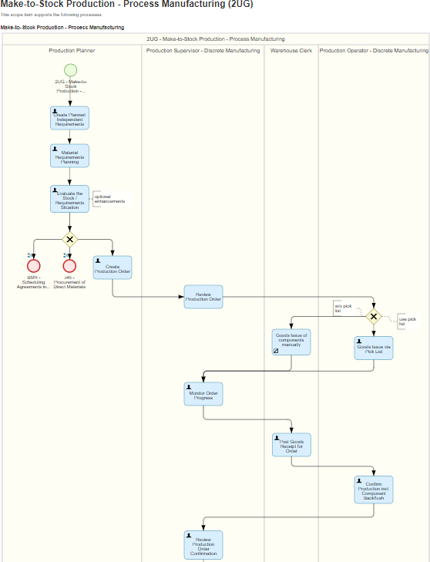

* + 1. **Order Release**

A Process order must be released, before it can be processed. Release triggers the following functions:

* Batch number for the order would be generated.
* Shop floor papers can be printed.
* Goods movements for the order can be executed.
* Confirmations for the order can be executed.
  + 1. **Batch Creation at the release of Process Order**

The Batch number would be generated for the semi-finished process orders. The same batch number would be copied to the finished process order.

Batch numbers would be system generated and would be maintained at the material level.

## Process Order Execution

It Comprises:

* Printing shop floor documents
* Carrying out material withdrawals

Withdrawing material components required in the manufacturing process in the form of goods issues from the warehouse.

* Recording confirmations i.e., recording the order progress status
* Carrying out in-process (phase-to-phase) quality hours
* Posting goods receipts from production

### Confirmations

Confirmations are used to document the processing of orders or operations such as production quantities, durations and activities. Data specified in a confirmation would be as follows:

* The quantity in an operation that was produced as yield, scrap; issued as components.
* How much work was actually done?
* Resources used for the operation/phase.

The following business transactions can be executed via confirmations:

* Updating order data (for example, quantities, activities, dates, status).
* Automatic goods receipt (for one operation per order max.).
* Reduction of the reserved capacity for the resources.
* Updating costs based on confirmed data.
* Updating MRP-relevant excess or missing quantities in the order.

### Information Required for Confirmations

The following information will be required for any confirmation of a production order:

|  |  |
| --- | --- |
| Information Required | Description |
| Order number &  operation number | Process order number to be produced. |
| Yield to confirm | Code of material to be produced. |
| Machine and labor  times | Actual execution times to be confirmed |
| Posting date | Date of actual production if different from current  date |

### Processes for Confirmation

At ARASCO confirmations would be carried out for each phase. For example, if we consider Food Manufacturing process, there would be one operation in the recipe called Tablet Manufacturing. However, this operation would be further divided into three phases i.e., Granulation, Compression and Coating. Every phase of the process order will be confirmed individually so that the quantity of the product can be tracked at shop level.

It is possible that the confirmations which were made were incorrect and the user wants to reverse/cancel confirmation. So, the system will allow the user to cancel the confirmation.

### Goods Issuance

Goods Issue (Dispensing) is issuance of raw/semi-finished materials from the warehouse/semi-finished store to the Process Order. When a process order is created, the system automatically generates a reservation for the required material components. Each material component of the order receives a separate item number within the reservation. Reserved materials can be withdrawn from the warehouse for the order that has been released. On withdrawal, the values of the material components are updated as actual costs in the order.

### Goods Receipt

The manufactured material is delivered to the finished or semi-finished stock in the system through the goods receipt process. Goods movement triggers the following transactions in the system:

* A material document is created to record the goods movement.
* The stock quantities of the material are updated.
* The stock values are updated in the material master record and the stock/consumption accounts are updated.

At ARASCO last operation of order will confirm Goods Receipt document of Semi- Finished and Finished has been created automatically through control key.

### Re-Processing

In this case, a new process order would be created MANUALLY via a different order type. A new batch number would not be generated in this case how-ever a new recipe and BOM would be required. The rest of the flow of the re-processing order would be similar to the normal process order.

### Process Order Configuration Data

At ARASCO, Process Order would be opened for the semi-finished and finished materials. The following order type(s) will be used at ARASCO:

|  |  |  |  |
| --- | --- | --- | --- |
| Plant | Plant Name | order type | Description |
| 1000 | ARASCO CORPORATE | PI01 | Process order (internal number a |
| 1000 | ARASCO CORPORATE | PI02 | Process order (external number a |
| 1000 | ARASCO CORPORATE | PI04 | Filling/packaging with "Assembly |
| 1102 | Dammam Feed Mill | D100 | DFM Feed Bulk |
| 1102 | Dammam Feed Mill | D200 | DFM Feed Bags |
| 1102 | Dammam Feed Mill | D300 | DFM-2 Feed Bulk |
| 1102 | Dammam Feed Mill | D400 | DFM-2 Feed Bags |
| 1102 | Dammam Feed Mill | D900 | DFM Rework |
| 1103 | Kharj Feed Mill | F100 | Fish Feed Bulk |
| 1103 | Kharj Feed Mill | F200 | Fish Feed Bags |
| 1103 | Kharj Feed Mill | H100 | Horse & Flaking Bulk |
| 1103 | Kharj Feed Mill | H200 | Horse & Flaking Bags |
| 1103 | Kharj Feed Mill | K100 | KFM Feed Bulk |
| 1103 | Kharj Feed Mill | K200 | KFM Feed Bags |
| 1103 | Kharj Feed Mill | K300 | KFM-2 Feed Bulk |
| 1103 | Kharj Feed Mill | K400 | KFM-2 Feed Bags |
| 1103 | Kharj Feed Mill | K900 | KFM Rework |
| 1104 | PREMIX Plant-Kharj | P100 | Pre-Mix Bulk |
| 1104 | PREMIX Plant-Kharj | P200 | Pre-Mix Bags |
| 1105 | ARCHEM plant-Dammam | A100 | ARCHEM Bulk |
| 1105 | ARCHEM plant-Dammam | A200 | ARCHEM Bags |
| 1410 | Food Corporate Plant | F100 | Fish Feed Bulk |
| 1410 | Food Corporate Plant | F200 | Fish Feed Bags |
| 1410 | Food Corporate Plant | H100 | Horse & Flaking Bulk |
| 1410 | Food Corporate Plant | H200 | Horse & Flaking Bags |
| 1410 | Food Corporate Plant | K100 | KFM Feed Bulk |
| 1410 | Food Corporate Plant | K200 | KFM Feed Bags |
| 1410 | Food Corporate Plant | K300 | KFM-2 Feed Bulk |
| 1410 | Food Corporate Plant | K400 | KFM-2 Feed Bags |
| 1410 | Food Corporate Plant | K900 | KFM Rework |
| 1420 | Breeder Plant | D100 | DFM Feed Bulk |
| 1420 | Breeder Plant | D200 | DFM Feed Bags |
| 1420 | Breeder Plant | D300 | DFM-2 Feed Bulk |
| 1420 | Breeder Plant | D400 | DFM-2 Feed Bags |
| 1420 | Breeder Plant | D900 | DFM Rework |
| 1420 | Breeder Plant | F100 | Fish Feed Bulk |
| 1420 | Breeder Plant | F200 | Fish Feed Bags |
| 1420 | Breeder Plant | H100 | Horse & Flaking Bulk |
| 1420 | Breeder Plant | H200 | Horse & Flaking Bags |
| 1420 | Breeder Plant | K100 | KFM Feed Bulk |
| 1420 | Breeder Plant | K200 | KFM Feed Bags |
| 1420 | Breeder Plant | K300 | KFM-2 Feed Bulk |
| 1420 | Breeder Plant | K400 | KFM-2 Feed Bags |
| 1420 | Breeder Plant | K900 | KFM Rework |
| 1430 | Hatchery Plant | F100 | Fish Feed Bulk |
| 1430 | Hatchery Plant | F200 | Fish Feed Bags |
| 1430 | Hatchery Plant | H100 | Horse & Flaking Bulk |
| 1430 | Hatchery Plant | H200 | Horse & Flaking Bags |
| 1430 | Hatchery Plant | K100 | KFM Feed Bulk |
| 1430 | Hatchery Plant | K200 | KFM Feed Bags |
| 1430 | Hatchery Plant | K300 | KFM-2 Feed Bulk |
| 1430 | Hatchery Plant | K400 | KFM-2 Feed Bags |
| 1430 | Hatchery Plant | K900 | KFM Rework |
| 1440 | Broiler Plant | F100 | Fish Feed Bulk |
| 1440 | Broiler Plant | F200 | Fish Feed Bags |
| 1440 | Broiler Plant | H100 | Horse & Flaking Bulk |
| 1440 | Broiler Plant | H200 | Horse & Flaking Bags |
| 1440 | Broiler Plant | K100 | KFM Feed Bulk |
| 1440 | Broiler Plant | K200 | KFM Feed Bags |
| 1440 | Broiler Plant | K300 | KFM-2 Feed Bulk |
| 1440 | Broiler Plant | K400 | KFM-2 Feed Bags |
| 1440 | Broiler Plant | K900 | KFM Rework |
| 1450 | Poultry Production Plant | F100 | Fish Feed Bulk |
| 1450 | Poultry Production Plant | F200 | Fish Feed Bags |
| 1450 | Poultry Production Plant | FD01 | FOOD - Slaughtering and Grading |
| 1450 | Poultry Production Plant | FD02 | FOOD - Cut-Ups |
| 1450 | Poultry Production Plant | FD03 | FOOD - Packaging |
| 1450 | Poultry Production Plant | FD04 | FOOD - Marination |
| 1450 | Poultry Production Plant | FD05 | FOOD - Rendering |
| 1450 | Poultry Production Plant | FD06 | FOOD - MDM process |
| 1450 | Poultry Production Plant | FD07 | FOOD - Returns/Frozen |
| 1450 | Poultry Production Plant | H100 | Horse & Flaking Bulk |
| 1450 | Poultry Production Plant | H200 | Horse & Flaking Bags |
| 1450 | Poultry Production Plant | K100 | KFM Feed Bulk |
| 1450 | Poultry Production Plant | K200 | KFM Feed Bags |
| 1450 | Poultry Production Plant | K300 | KFM-2 Feed Bulk |
| 1450 | Poultry Production Plant | K400 | KFM-2 Feed Bags |
| 1450 | Poultry Production Plant | K900 | KFM Rework |
| 1460 | Cold Storage Plant | F100 | Fish Feed Bulk |
| 1460 | Cold Storage Plant | F200 | Fish Feed Bags |
| 1460 | Cold Storage Plant | H100 | Horse & Flaking Bulk |
| 1460 | Cold Storage Plant | H200 | Horse & Flaking Bags |
| 1460 | Cold Storage Plant | K100 | KFM Feed Bulk |
| 1460 | Cold Storage Plant | K200 | KFM Feed Bags |
| 1460 | Cold Storage Plant | K300 | KFM-2 Feed Bulk |
| 1460 | Cold Storage Plant | K400 | KFM-2 Feed Bags |
| 1460 | Cold Storage Plant | K900 | KFM Rework |
| 1470 | Arasco Food Trading Plan | F100 | Fish Feed Bulk |
| 1470 | Arasco Food Trading Plan | F200 | Fish Feed Bags |
| 1470 | Arasco Food Trading Plan | FD01 | FOOD - Slaughtering and Grading |
| 1470 | Arasco Food Trading Plan | FD02 | FOOD - Cut-Ups |
| 1470 | Arasco Food Trading Plan | FD03 | FOOD - Packaging |
| 1470 | Arasco Food Trading Plan | FD04 | FOOD - Marination |
| 1470 | Arasco Food Trading Plan | FD05 | FOOD - Rendering |
| 1470 | Arasco Food Trading Plan | FD06 | FOOD - MDM process |
| 1470 | Arasco Food Trading Plan | FD07 | FOOD - Returns/Frozen |
| 1470 | Arasco Food Trading Plan | H100 | Horse & Flaking Bulk |
| 1470 | Arasco Food Trading Plan | H200 | Horse & Flaking Bags |
| 1470 | Arasco Food Trading Plan | K100 | KFM Feed Bulk |
| 1470 | Arasco Food Trading Plan | K200 | KFM Feed Bags |
| 1470 | Arasco Food Trading Plan | K300 | KFM-2 Feed Bulk |
| 1470 | Arasco Food Trading Plan | K400 | KFM-2 Feed Bags |
| 1470 | Arasco Food Trading Plan | K900 | KFM Rework |
| 1471 | Further Process Production | F100 | Fish Feed Bulk |
| 1471 | Further Process Production | F200 | Fish Feed Bags |
| 1471 | Further Process Production | FD01 | FOOD - Slaughtering and Grading |
| 1471 | Further Process Production | FD02 | FOOD - Cut-Ups |
| 1471 | Further Process Production | FD03 | FOOD - Packaging |
| 1471 | Further Process Production | FD04 | FOOD - Marination |
| 1471 | Further Process Production | FD05 | FOOD - Rendering |
| 1471 | Further Process Production | FD06 | FOOD - MDM process |
| 1471 | Further Process Production | FD07 | FOOD - Returns/Frozen |
| 1471 | Further Process Production | FD30 | FOOD - Burgers and Nuggets |
| 1471 | Further Process Production | H100 | Horse & Flaking Bulk |
| 1471 | Further Process Production | H200 | Horse & Flaking Bags |
| 1471 | Further Process Production | K100 | KFM Feed Bulk |
| 1471 | Further Process Production | K200 | KFM Feed Bags |
| 1471 | Further Process Production | K300 | KFM-2 Feed Bulk |
| 1471 | Further Process Production | K400 | KFM-2 Feed Bags |
| 1471 | Further Process Production | K900 | KFM Rework |
| 1480 | Sheep Rearing and Production | F100 | Fish Feed Bulk |
| 1480 | Sheep Rearing and Production | F200 | Fish Feed Bags |
| 1480 | Sheep Rearing and Production | FD01 | FOOD - Slaughtering and Grading |
| 1480 | Sheep Rearing and Production | FD02 | FOOD - Cut-Ups |
| 1480 | Sheep Rearing and Production | FD03 | FOOD - Packaging |
| 1480 | Sheep Rearing and Production | FD04 | FOOD - Marination |
| 1480 | Sheep Rearing and Production | FD05 | FOOD - Rendering |
| 1480 | Sheep Rearing and Production | FD06 | FOOD - MDM process |
| 1480 | Sheep Rearing and Production | FD07 | FOOD - Returns/Frozen |
| 1480 | Sheep Rearing and Production | FD20 | FOOD - Red Meat Products |
| 1480 | Sheep Rearing and Production | H100 | Horse & Flaking Bulk |
| 1480 | Sheep Rearing and Production | H200 | Horse & Flaking Bags |
| 1480 | Sheep Rearing and Production | K100 | KFM Feed Bulk |
| 1480 | Sheep Rearing and Production | K200 | KFM Feed Bags |
| 1480 | Sheep Rearing and Production | K300 | KFM-2 Feed Bulk |
| 1480 | Sheep Rearing and Production | K400 | KFM-2 Feed Bags |
| 1480 | Sheep Rearing and Production | K900 | KFM Rework |
| 1501 | IDAC Mérieux NutriSciences | PI01 | Process order (internal number a |
| 1501 | IDAC Mérieux NutriSciences | PI02 | Process order (external number a |
| 1501 | IDAC Mérieux NutriSciences | PI04 | Filling/packaging with "Assembly |
| 1600 | Central Warehouse | PI01 | Process order (internal number a |
| 1600 | Central Warehouse | PI02 | Process order (external number a |
| 1600 | Central Warehouse | PI04 | Filling/packaging with "Assembly |
| 1601 | Head Office | PI01 | Process order (internal number a |
| 1601 | Head Office | PI02 | Process order (external number a |
| 1601 | Head Office | PI04 | Filling/packaging with "Assembly |
| 1602 | Riyadh Branch | PI01 | Process order (internal number a |
| 1602 | Riyadh Branch | PI02 | Process order (external number a |
| 1602 | Riyadh Branch | PI04 | Filling/packaging with "Assembly |
| 1603 | Al-Kharj Branch | PI01 | Process order (internal number a |
| 1603 | Al-Kharj Branch | PI02 | Process order (external number a |
| 1603 | Al-Kharj Branch | PI04 | Filling/packaging with "Assembly |
| 1604 | Dammam Branch | PI01 | Process order (internal number a |
| 1604 | Dammam Branch | PI02 | Process order (external number a |
| 1604 | Dammam Branch | PI04 | Filling/packaging with "Assembly |
| 1605 | Wadi Al-Dawasir Branch | PI01 | Process order (internal number a |
| 1605 | Wadi Al-Dawasir Branch | PI02 | Process order (external number a |
| 1605 | Wadi Al-Dawasir Branch | PI04 | Filling/packaging with "Assembly |
| 1606 | Sajar Branch | PI01 | Process order (internal number a |
| 1606 | Sajar Branch | PI02 | Process order (external number a |
| 1606 | Sajar Branch | PI04 | Filling/packaging with "Assembly |
| 1607 | Al-Qassim Branch | PI01 | Process order (internal number a |
| 1607 | Al-Qassim Branch | PI02 | Process order (external number a |
| 1607 | Al-Qassim Branch | PI04 | Filling/packaging with "Assembly |
| 1608 | Hail Branch | PI01 | Process order (internal number a |
| 1608 | Hail Branch | PI02 | Process order (external number a |
| 1608 | Hail Branch | PI04 | Filling/packaging with "Assembly |
| 1609 | Al-Jouf Branch | PI01 | Process order (internal number a |
| 1609 | Al-Jouf Branch | PI02 | Process order (external number a |
| 1609 | Al-Jouf Branch | PI04 | Filling/packaging with "Assembly |
| 1610 | Tabuk Branch | PI01 | Process order (internal number a |
| 1610 | Tabuk Branch | PI02 | Process order (external number a |
| 1610 | Tabuk Branch | PI04 | Filling/packaging with "Assembly |
| 1611 | Jeddah Branch | PI01 | Process order (internal number a |
| 1611 | Jeddah Branch | PI02 | Process order (external number a |
| 1611 | Jeddah Branch | PI04 | Filling/packaging with "Assembly |
| 1612 | Najaran Branch | PI01 | Process order (internal number a |
| 1612 | Najaran Branch | PI02 | Process order (external number a |
| 1612 | Najaran Branch | PI04 | Filling/packaging with "Assembly |
| 1613 | Khamis Musayat Branch | PI01 | Process order (internal number a |
| 1613 | Khamis Musayat Branch | PI02 | Process order (external number a |
| 1613 | Khamis Musayat Branch | PI04 | Filling/packaging with "Assembly |
| 1701 | Al Kharj MEFSCO | M100 | MEFSCO Corn Cleaning |
| 1701 | Al Kharj MEFSCO | M200 | MEFSCO Starch Slurry |
| 1701 | Al Kharj MEFSCO | M300 | MEFSCO Co-Products |
| 1701 | Al Kharj MEFSCO | M400 | MEFSCO Starch Bags |
| 1701 | Al Kharj MEFSCO | M500 | MEFSCO Glucose Semi Finished Bul |
| 1701 | Al Kharj MEFSCO | M600 | MEFSCO Glucose Bulk Finished |
| 1701 | Al Kharj MEFSCO | M700 | MEFSCO Glucose Drums |
| 1701 | Al Kharj MEFSCO | M800 | MEFSCO Re-Work Order |
| 1701 | Al Kharj MEFSCO | M900 | MEFSCO Re-Packing Order |
| 2101 | Grains Trading Unit | D100 | DFM Feed Bulk |
| 2101 | Grains Trading Unit | D200 | DFM Feed Bags |
| 2202 | ASG Aqua Plant | PI01 | Process order (internal number a |
| 2202 | ASG Aqua Plant | PI02 | Process order (external number a |
| 2202 | ASG Aqua Plant | PI04 | Filling/packaging with "Assembly |

*Note:- There are so many redundant order types defined in SAP, need to delete the un used order types.

## Order Closing

Order closing involves the TECO, Order settlement and Close.

### Technical Completion of Production Order (TECO)

Technical completion means ending a production order from a logistical viewpoint. This function is used, if the execution of an order has already been completed.

The following actions are executed if an order is set to Technically Complete.

* The order is not relevant for MRP planning
* Reservations are deleted
* Capacity requirements are deleted
* Purchase requisitions for external operations or non-stock materials are deleted
* The order and its operations receive the system status Technically Completed (TECO)

### Process Order Settlement

When a production order is settled, the actual costs incurred for the order are settled to one or more receiver cost-objects (for example, to the account for the material produced). For please refer to the Controlling Blueprints.

### Closing Process Order

After a process order has been settled, its status is set as *Closed* (CLSD). Closed orders have following characteristics:

* No more costs can be posted to the order, that is, confirmations and goods movements are no longer permitted for the order.
* The order can no longer be changed. Exceptions to this are revoking the CLSD status and setting the deletion flag.

All actions relating to the status [technically completed](http://help.sap.com/saphelp_46c/helpdata/en/a3/664a3397e311d1b5a70000e8359890/content.htm) (TECO) are executed.

### Prerequisites for Order Close

Prerequisites for setting the CLSD status are:

* The order must have the status *Released* (REL) or *technically completed*

(TECO)

* The order balance must be 0
* There can be no future change records from confirmation processes.
* A process order after being closed can be set for Archiving run.

# Re-processing

## Process Definition

It is a process when QC decides that the bulk produced cannot be released for packaging and it requires further processing. In this case one time process order is manually created and one time BOM and Master Recipe is also created. Re- processing is un-planned production.

## Re-processing OF Semi-Finished and Finished

In this case, create new alternative BOM with required components also add header material in components list and create new recipe with required operations only and create new production version.

Production manager would create a new process order MANUALLY via a different order type.

# Reports

**SAP Standard Reports**

Below is the selected list of SAP standard reports for PP module and also include information on which can be utilized in case of any changes in business processes (for

e.g., Addition of new Resource, mass changes in BOM etc.)

|  |  |  |  |
| --- | --- | --- | --- |
| Sr.# | Name & Description | Availability in SAP | Remarks |
| 1 | Production Order Information System | Production Order Header | COOISPI |
| 2 | Production Order Information System | Items (Individual items) | COOISPI |
| 3 | Production Order Information System | Operations Overview | COOISPI |
| 4 | Production Order Information System | Capacities | COOISPI |
| 5 | Production Order Information System | Components | COOISPI |
| 6 | Production Order Information System | Confirmations | COOISPI |
| 7 | Production Order Information System | Purchase Requisitions | COOISPI |
| 8 | Production Order Information System | Document Links | COOISPI |
| 9 | Production Order Information System | Automatic Goods Movement | COOISPI |
| 10 | Production Order Information System | Documented Goods Movement | COOISPI |
| 11 | Production Order Information System | Goods movements with error | COOISPI |
| 12 | Order Progress Report |  | CO46 |
| 13 | Material BOM Browser |  | CSMB |
| 14 | Mass Changes |  | CS20 |
| 15 | Where-Used List | Material | CS15 |
| 16 | BOM Comparison |  | CS14 |
| 17 | Change Documents | Material BOM | CS80 |
| 18 | Replace |  | CA85 |
| 19 | Resource Information System |  | CR60 |
| 20 | Resource List |  | CR05 |
| 21 | Assignment of Resource to Cost  Center |  | CR06 |
| 22 | Replace Recipe |  | CA85N |
| 23 | Change Documents |  | CA61 |
| 24 | Missing Parts Information System |  | CO24 |
| 25 | Standard Analysis | Resource | MCP7 |
| 26 | Standard Analysis | Operation | MCP1 |
| 27 | Standard Analysis | Material | MCP5 |
| 28 | Standard Analysis | Production Order | MCP3 |

|  |  |  |  |
| --- | --- | --- | --- |
| 29 | Standard Analysis | Material Consumption | MCRE |
| 30 | Standard Analysis | Product Cost | MCR1 |

Below is the selected list of standard SAP reports pertaining to Materials Management (MM) module covering both the Inventory Management (plant, material, storage location etc.) and for its relevance in PP module.

|  |  |  |  |
| --- | --- | --- | --- |
| Sr. # | Name & Description | Availability in SAP | Remarks |
| 1 | Goods Receipt w.r.t. Movement Types and Document Type | MB51 |  |
| 2 | Issuances / Receipts as on Posting date | MB5B |  |
| 3 | Storage Location Analysis (Value Received/Value Issued). | MCBC |  |
| 4 | Plant Analysis (Value Received/Value Issued). | MCBA |  |
| 5 | Material Analysis (Value Received/Value Issues) | MCBE |  |
| 6 | Warehouse Stocks of Material(s) | MB52 |  |
| 7 | Stock Overview | MMBE |  |
| 8 | Stock / Requirements List | MD04 |  |

# Advantage of S4 Hana Production planning VS ECC Production Planning.

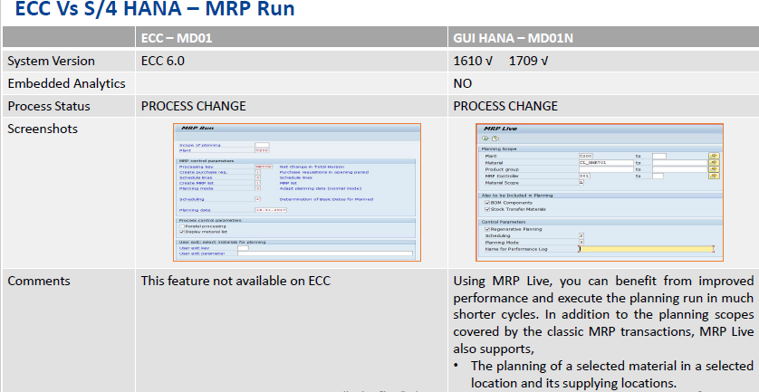

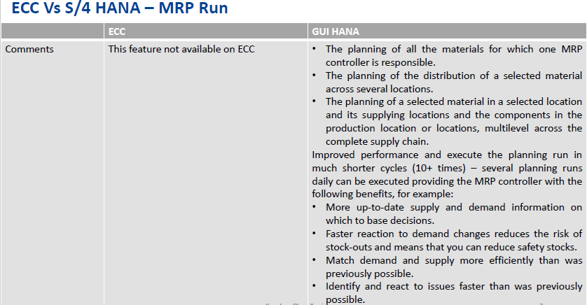

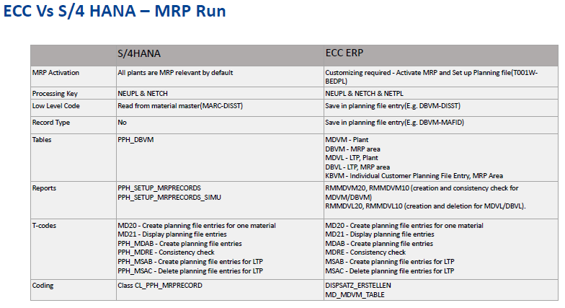

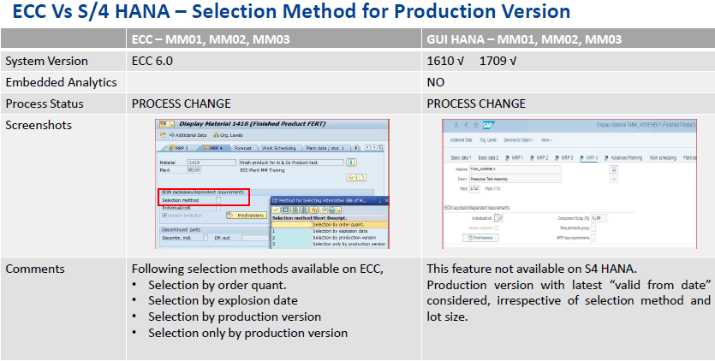

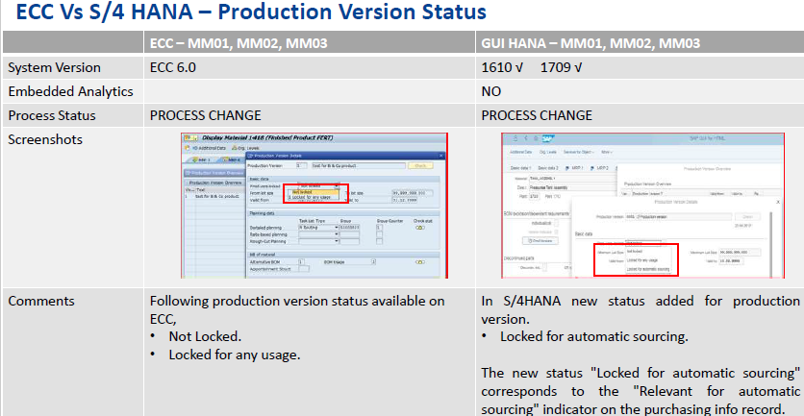

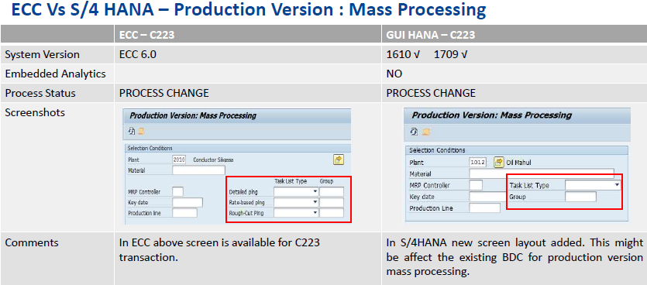

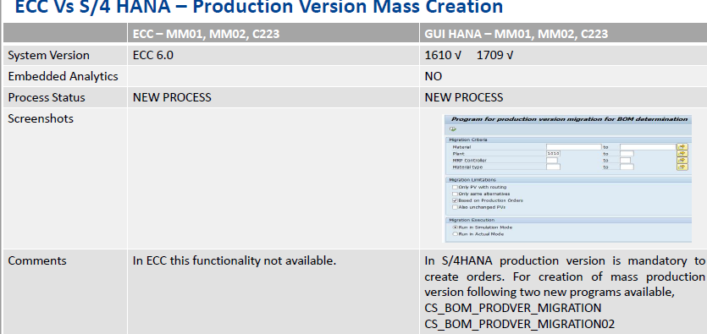

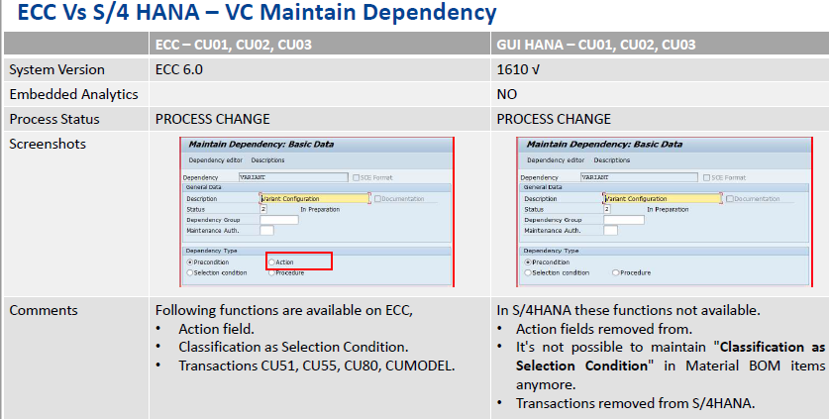

# Business Process Master List

We propose the following BPML for Production Planning

|  |  |  |
| --- | --- | --- |
| **Business Process-L1** | **Business Process-L2** | **Business Process-L3** |
| Master Data | Bill of material | Creation and change of Bill of material |
|  | Resource | Creation and change of Resource |
|  | Master Recipe | Creation and change of Master Recipe |
|  | Production Versions | Creation and change of Production Versions |
| Processes | Sales and Operation Planning | Creation of Product Group |
|  |  | Create plan in inactive version |
|  |  | Disaggregate product group plan |
|  |  | Convert inactive to active version |
|  |  | Transfer SOP Plan to Demand management |
|  | Demand Management | Create, Change Display PIR |
|  | Master Production Scheduling | RUN MRP |
|  | Material Requirement Planning | RUN MRP |
|  | Planned order conversion | Convert planned order to process order |
|  | Planned order | Create, Change Display Planned order |
|  | Process order | Create, Change Display Process order |
|  |  | Release Process order |
|  |  | Goods issue to process order |
|  |  | Confirm Process order |
|  |  | Goods Receipt process order |
|  |  | TECO |
|  |  | Close |
|  | Rework | Create, Change Display Rework order |

# Proposed Scope of work

Functional Scope

|  |  |  |
| --- | --- | --- |
| **Area** | **Business Process** | **Remarks** |
| Master Data | Bill of material |  |
|  | Resource |  |
|  | Master Recipe |  |
|  | Production Versions |  |
| Processes | Sales and Operation Planning |  |
|  | Demand Management |  |
|  | Master Production Scheduling |  |
|  | Material Requirement Planning |  |
|  | Planned order conversion |  |
|  | Planned order |  |
|  | Process order |  |
|  | Rework |  |

# Technical Scope

* 1. Existing RICEF

The list of existing customizations for ARASCO is given below:

Frequently used RICEFW:

|  |  |
| --- | --- |
| ZPIR_2 | Wincos Error Logs information |
| ZPP010 | Tcode for Process Order variance rep |
| ZPP012 | PP: Wincos Process Order Confirm. |
| ZPP014 | Order Confirmation Report |
| ZPP015 | Wincos-SAP CMDUID for re-processing |
| ZPP02 | PP02 Upload |
| ZPP020 | Process Order Conf. Wincos for DFM |
| ZPP021 | Food Production Report |
| ZPP022 | Material Reservation Slip |
| ZPP026 | Production Report |
| ZPP028 | COGI Deleted Error Log report |
| ZPP037 | Tcode for ZPPE_PROCESSORD_PROC_REMOV |
| | BS_Brill_Q | SI_BRILL_PP_BOM_OB | | | PI Interfaces |
| | BS_Brill_Q | SI_BOM_TRANS_OB | | | PI Interfaces |
| | BS_QAS_200 | SI_PP_TONNAGE_OB | | | PI Interfaces |
| BS_QAS_200 | SI_PP_Contamination_ADS01_OB | PI Interfaces |
| BS_QAS_200 | SI_PP_Contamination_DFM_OB | PI Interfaces |
| BS_QAS_200 | SI_PP_Contamination_OB | PI Interfaces |
| BS_SA_ENSIAB_BUHLER_Q | SI_BUHLER_PP_GRGI_Activities_OB | PI Interfaces |
| BS_QAS_200 | SI_BUHLER_PP_ProcessOrder_BOM_N_OB | PI Interfaces |
| BS_QAS_200 | SI_BUHLER_PP_ProcessOrder_BOM_N_DFM_OB | PI Interfaces |
| BS_QAS_200 | SI_UPD_EXPORTCOMMANDTABLE_ADS_OB | PI Interfaces |
| BS_QAS_200 | SI_UPD_EXPORTCOMMANDTABLE_DFM_OB | PI Interfaces |
| BS_QAS_200 | SI_UPD_EXPORTCOMMANDTABLE_OB | PI Interfaces |
| ZPP_F_RESERVATION | Forms |

* 1. Integration
* Currently there is integration of PP with Wincos 3rd party solution.
* It is recommended to integrate PAI with SAP PP in Mefsco
* There is a integration required with MTech for food business.
* In Brill premix plant need to be integrated with SAP
  1. RICEF Requirement
* It was observed that in Mefsco PAI system is used for Performance reports which need to be integrated with SAP.
* It is recommended to combine all the reports with the similar objectives to optimized the number of RICEF objects.

**Currently used RICEFW objects:**

|  |  |  |  |  |  |
| --- | --- | --- | --- | --- | --- |
| **Reports** | **Interfaces** | **Conversions** | **Enhancements** | **Forms** | **Workflow** |
| 8 | 12 | 1 | 2 | 2 | 0 |